User Guide for Asian Studies Digital Portfolio

Asian Studies Portfolio Website– A visual, living resume.
(A requirement for the Asian Studies Undergraduate Certificate or BPHIL-IAS/Asian Studies)

Useful Information Prior to Beginning Your Portfolio Website

Why Should I Create an Asian Studies Portfolio Website?
The purpose of the website is for you to create a succinct and dynamic portfolio that demonstrates who you are, what you want to become, and what you want someone to know about your interests in a global theme or your understanding of a global issue. The site will demonstrate how students are informed about, as well as engaged with, a global issue through their various curricular and co-curricular experiences at Pitt. It should also be infused with your personality through the use of images, testimonies, and pros, facilitating a portrayal of the breadth and depth of the individual.

When Do I Build My Website and Who is My Audience?
You will begin the process after enrollment in either the certificate or BPHIL/ IAS programs. The intended audience for the site will vary according to your academic year at Pitt, evolving over time, with the expectation that you will continue to update the website during each year with any new experiences, interests, and/or related materials.

Student Status | Targeted Audience
Freshmen/Sophomores | Academic Advisors, a favorite high school teacher, and/or a person who was instrumental in facilitating your interest in global issues
Juniors/Seniors | Prospective Employers, Internship hosts, Prospective Graduate School Faculty, and/or Admissions Administrators

How Will I Utilize My Website After Graduation?
The student-created website will continue to serve you, as an alum, by demonstrating your intellectual inquiry, professional development, and community engagement—it can be thought of as a living and dynamic resume, capable of being easily updated to reflect additional experiences and knowledge gained after graduation. Also, we encourage you to include links to your website on LinkedIn to further your professional network, and use your portfolio as a resource or testimonial for applications to graduate schools and employment. The Asian Studies Center will also share the websites to demonstrate student experiences to prospective students, faculty, and administration.

This guide has two sections for your reference as you work on your portfolio:
- Introducing the basics of how to use the site and customize it with your information
- Specific instructions for each page (Home page, Coursework, Gallery, etc)

Basics
Activate Your Account and Log In
- Follow the link in your email to activate your account. You will be given a username and password, so be sure to write your log in information down for later.
  - Click the Log In link and enter your new username and password.
  - You will be taken to your Dashboard, which acts as a portal for you to make changes and updates to your portfolio.
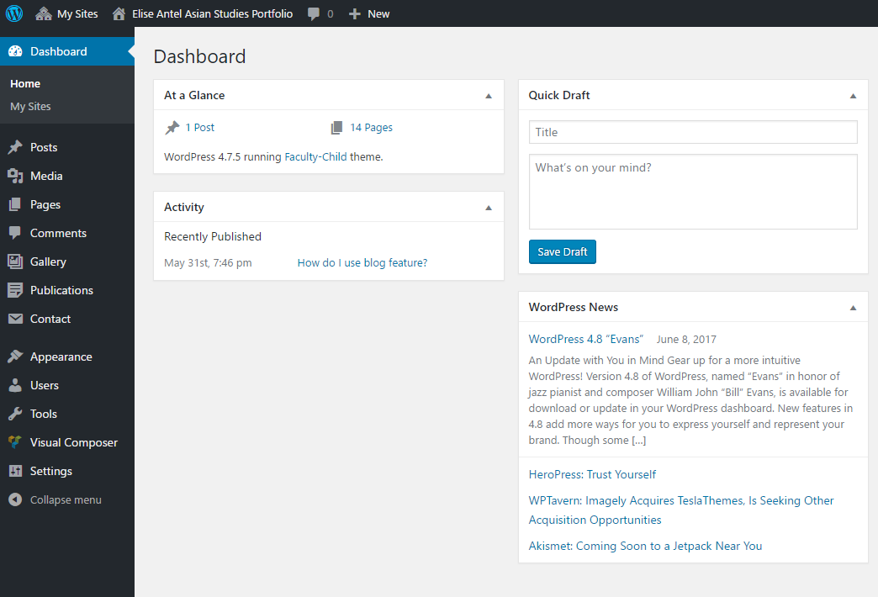
  - To view your site, locate your site’s name (Student Name Asian Studies Portfolio) on the dark grey bar on the top of the page. Hover over the site name and click “Visit Site.”
  - Look around and get familiar with the different pages and sections that are already built into the site! You will be able to customize and update nearly every part of your site.
Personalize with Your Name and Photo
- Once you explore your site, it’s time to start editing. To add your name and photo to your site, you’ll need to get back to your Dashboard.
  - Mouse over the name of your site on the black bar at the top of the page
    - Click on Dashboard.
    - On the menu on the left-hand side mouse over “Appearance”
      - Click on “Theme Options” (not “Theme”)
        - Insert your name, center affiliation and university, upload a picture (you should experiment with the kind of image you want to have there!)
        - It’s best to upload a square image in order to make sure your image does not look distorted on the site.
        - After uploading your image, be sure to click “Set File”
        - Be sure to save your changes.
        - Click your site name at the top to see your changes.
- How to Change the Site Identity
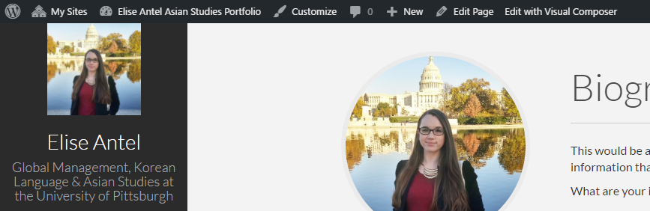
  - You also have the option to change the overall name of your site, which is the name that shows up in your internet browser and the name that will appear on the top menu of your sites when you are editing.
This is your site identity, which you can change by clicking “Customize.”

  - Click “Customize” on the black bar at the top of the page
    - On the menu on the left hand of the page click on Site Identity
      - Change Site Title and Tagline. You may also change the site icon if you like
        - Press save and close the customize menu

Back End Editor versus Front End Editor
When adding your information into the template pages provided, you have two options for how you would like to edit the pages: back end and front end editors. Both modes have different strengths, and one mode may be easier to use for certain template pages, so we suggest that you get familiar with both.
- Back End Editor
  - This refers to editing page through your Dashboard. In this mode, you will be able input content into fields, but you will not see the final visual layout of the page until you Publish your changes and go back to your site.
  - The back end editor is accessed by going to your Dashboard, hovering over “Pages” on the sidebar menu, and clicking “All Pages”
    - From here you can click on the name of any page that you would like to edit and you will be taken to the back-end editor for that page.
- Front End Editor
  - The Front end editor is useful if you would like to edit a page while seeing it exactly as it will appear on the site when you publish your changes.
    - You can access the front page editor by navigating to the page you want to edit on your site and clicking “Edit with Visual Composer” located in the dark grey bar at the top of the page.
    - Then you can input new information by hovering over the element you want to edit and clicking the Pencil Icon on the green menu that appears.
Inputting Your Information into the Template Pages and Adding New Elements
- Work on the pages already in the system – this helps us to maintain consistency across all student portfolios.
  - To use the Front End Editor, click on the page you are planning on working.
    - Click on “Edit with Visual Composer” on the top of the page
    - Hover over the section you would like to work on and click the pencil icon on the green menu that pops up to make changes
Use this button to move the section or whole element up/down/left/right
Delete section or element

Duplicate section or element
Edit

    - Click “Save Changes”
  - Adding images, text boxes, videos, or other content using the visual composer
    - You can use either the frontend or backend editor for this depending on your comfort.
    - Go to your editor and mouse around to spot where you want to add. Click on the + button and choose the kind of additional content.
    - Be sure to hit the save changes button when you are filling in content fields AND when you are happy with the content, be sure to click the “Update” button at the top of the page before you move away from the page. Otherwise, your changes will not appear on your website.
  - Adding documents to the website
    - Links to documents can be added into textboxes
      - Click add textbox
        - Click add media
        - Upload the document
  - Adding hyperlinks to text
    - Click on the textbox and click on the edit icon (pencil)
    - Highlight the text that you want to create as a hyperlink
      - Click on the hyperlink button (it looks like a chain link)
      - Insert the URL
Saving Changes
In order to make changes to the information or layout of your site permanent, make sure to save your changes by clicking “Update,” “Publish,” or “Save Changes.” Usually this button will be a dark blue color on the upper right side of the page.
Undoing Changes
There is no Undo button in WordPress. You should be extra careful when deleting elements or sections.
- If you do delete a section or element by mistakes, you can potentially bring it back by NOT clicking Update or Publish Changes, and instead refreshing the pages in your browser. Doing this will reverse any changes you made since the last time you saved or updated. This will not work in all situations, but can be helpful sometimes.
Adding Pages to the Site
- Go to your dashboard
  - Click on the pages tab
  - Click on add new
    - Enter the title of the new page
    - Go to either the backend or frontend editor and use the spaces to build the page you would like to have
    - BE SURE TO CLICK PUBLISH before you are done

Adding New Pages to the Menu
- Mouse over Appearances and click on Menus
  - In the box on the left hand size labeled pages find the page you would like to add, check the box to the left of the page name, and click add to menu
  - In the menu structures box on the right hand side find the new menu item and click on the arrow on the right hand side to show a drop down menu.
  - Move the menu item to the spot you would like to be
  - OPTIONAL: to add a menu icon, go to Dashboard, then Appearance, then Menus, and find the page you want to add the icon to in the Menu Structure. Click the arrow next to the name of the page and find the box titled “CSS Classes”.
    - If this box does not show up, go to the upper right corner of the page and click screen options. Make sure there is a check in the box next to CSS Classes.
  - To add an icon, you need to type the code for the Font Awesome icon you would like to use. Using Font Awesome in the css classes box, type “fa”, space, and then the name of the font awesome icon you would like to use (For example, if you wanted to use the bath font awesome icon you would type “fa fa-bath”). For a list of font awesome icons and their codes, click here: http://fontawesome.io/icons/

What if I want to deactivate a page for now, but not delete it permanently?
- If you are working on a certain section and would like to remove it from your site while it is under construction, you can simply remove the section from the menu so that others cannot access the page directly. In order to deactivate a certain page for now (but still have the ability to bring it back later)
      - Remove section from the side menu
        - On the Dashboard, Select “Appearance” and then “Menus”
        - Use the drop down menu to select the menu you want to edit (usually the Main Menu) and press select.
        - Under Menu Structure, locate the section you would like to remove and click the arrow.
        - Click “remove” to remove the section from your menu.
        - Be sure to “Save Menu” before leaving the page.
        - Go back to your site to make sure the changes worked.
      - How can I get to the page to work on it, while it is off the menu?
        - If you removed a page from the menu, but want to access it to make changes, go to Dashboard, then Pages, and All pages.
        - Hover over the section you want to work on and click “edit”.
        - You can edit the page in either the front end mode or back end mode.
        - Make sure to publish your changes.
How do I put the deactivated page back on the menu?
      - Once you are ready to put the page back on the menu for public view, you will need to add the section back onto the menu.
        - On the Dashboard, Select “Appearance” and then “Menus”
        - Use the drop down menu to select the menu you want to edit (usually the Main Menu) and press select.
        - In the Pages section on the left side, scroll to find the page you want to add and click the check box. (Note: you may need to click view all if you can’t find the page you want).
        - Click “Add to Menu”
        - Click “Save Menu” at the top of page.
          - This will add the page to the bottom of the menu.
        - If you would like to move it up on the menu to a higher location, go to menu structure and click on the section.
        - Click Move “up one” until it is in the desired location.

Specific Instructions for Each Page
Coursework
This Page is easiest to edit in the Back End Editor.
- Go to Dashboard, then “Pages”, and “All Pages”
  - Hover over “Coursework” and click “edit”.
  - Hover over the section you want to edit and click on the pencil icon in the green pop-up menu to edit.
  - To change the Course Name
    - Click on the tab you want to edit in the element and then click the pencil icon on the ORANGE menu that appears.
  - To add more courses
    - Click on an existing course tab and click the duplicate icon on the orange menu.
    - Edit the new section with your new course info
  - You can also delete extra tabs if you have not yet taken at least 5 courses you want to display
    - Click the tab of the course you want to delete
    - Click the trash icon on the orange menu to delete that course
- Be sure to click Update to save your changes.

Language Study
Can be edited in Front End or Back End Editor
- You can also add new elements to this page to link to projects or articles you have written in your target language.
* If you want to add videos of you using your language skills to this page, follow the instructions for Adding Embedded Videos in the Study Abroad section of this guide.
* If you want to add a button to link directly to a project you completed in your target language, follow the instructions for Adding Buttons under the Internships & Employment section of this guide.

Research
Can be edited in Front End or Back End Editor
- To add a new research project to this page
  - Front End
    - Hover of the element
    - Click on the orange + that appears and select “research project” from the list of new elements
    - Click on the gray + that appears and select single research project.
    - Input the information you want to include for this project. You can add an abstract or link to the project in the text field.
    - Save and publish your changes.
  - Back End
    - Click on the gray “+” and select “research project” and then “single project”
    - Input the information you want to include for this project. You can add an abstract or link to the project in the text field.
    - Save and publish your changes.

Study Abroad
Can be edited in Front End or Back End Editor
- This page has a built in image gallery which you can edit to include photos you took during study abroad.
Adding Embedded Videos
You can include travel vlogs or other video of your time abroad using the Video element.
- Using the back end editor, click the gray + on the bottom of the page.
  - Select “Video Player” in the list of elements.
  - In the Video Player menu, add a title above your video in the widget title field.
  - Paste the URL of your video and choose how you want to align the video.
  - Save Changes
- If you the video to be less than the full size of the screen, you can adjust the column settings f the page using the back end editor.
  - In the gray box surrounding the video player element, locate the three icons in the upper left corner
    - These are used to position the section, adjust the columns, and to add columns.
    - The second icon (looks like horizontal lines) will popup with more options of how to distribute the content of that section in columns of various widths.
    - Click your desired layout of columns and adjust your content to fit.

Community Engagement
Can be edited in Front End or Back End Editor
- Consider customizing this page by adding photos and additional elements

Internships & Employment
Can be edited in Front End or Back End Editor
Editing the Position Name Dates and Description
- To change the position name, hover over the position element and click the pencil icon
  - Input your information for the position title and location.
    - NOTE: any content added to the HTML Content field in the position element will not display on your site.
  - Enter the start and end dates for this position.
  - Save changes and Update
- The description for each position is housed in a separate text box element directly under the position element.
  - Hover over the description field and Click on the pencil icon in the green popup menu.
  - Save Changes.
Adding Additional Positions
- The template for this page has several space for you to input your position information already, but you may want to add more positions depending on what experiences you have.
    - To duplicate the position using the BACK END EDITOR, click on the grey duplicate icon for the wrapper (which is a grouped field that contains both the position title element and a text box for the job description.)
    - To duplicate the position using the FRONT END EDITOR, hover over an existing position and click the duplicate icon in the orange popup menu for the Wrapper.
    - Now you can edit the position and text fields by clicking the pencil icon in the popup menus.
Adding Buttons to link to Publications, Blog Posts, or other Pages on your site
- If you wrote an article or paper during an internship that you already added to your publications on your site or want to send the reader to your Research page, you can add a button that links to that publication or page straight from the internships page.
  - On the Internships & Employment page, go to the position that you want to add the button to.
  - Underneath the description textbox, click the grey + to add a new element.
    - Select the Button element from the list. (Use the search box if you are having a hard time finding it.)
    - Set the text to the text that you would like to appear on the button.
    - Next, click “Select URL” to choose where the button will link to.
      - You can either type in a direct URL or select an existing page, publication, gallery item, or blog post from the list.
      - Once you input the URL or select from the list, click “Set Link”
    - You can adjust the style, color, and size of the button using the additional fields.
      - Consider if you want the button to be centered in the section or to the left or right side and change this using Alignment.
      - You can also add an icon to appear on the button next to the button text.
  - Save changes and Update.

Gallery
Editing or Adding Images and Titles to the Gallery
- Mouse over the name of your site on the black bar at the top of the page
  - Click on dashboard
    - Click on Gallery
      - If you want to edit an old Gallery post- Click on the post and begin editing
      - If you want to start a new Gallery submission click on the “Add New” button at the top of the page
        - In the box on the right side of the page, click the button to “Set Image” in the section called Featured Image, to select an existing image or to upload a new image.
        - Enter the title of the Image (it should be short) in the title box
        - If you would like to caption the image you can do so in the excerpt box.
        - Once you have set the image, title, and caption, click “Publish” in the top right section of the page to save changes.
      - To delete a gallery submission mouse over the title of the submission and click Trash

Papers, Presentations, Publications
Adding papers, presentations or other publications
- To add papers, presentations, resumes, and other publications to the Publications page, click on to your dashboard.
  - Click on Publications
  - Click “Add New” and fill in as much or as little of the information as you would like. You DO NOT need to upload the documents here. It is more than acceptable to just record your work or to add the abstract for a piece rather than the whole document. If you do want to add papers you are welcome to do so.
  - You can select which type of entry you are uploading in the Publication Types box on the right side of the page. (Paper, presentations, publication, capstone paper, resume, etc)
    - If you would like to add a custom category, click “add a new category” under Publication Types.
  - To set a cover image, click “Set Cover” on the right side of the page under Publication Cover Image.
  - These entries will automatically populate your publications page.
  - We strongly encourage you to turn off comments.
  - We also STRONGLY encourage you to care for your personal data, and strip phone numbers and addresses off of resumes meant to be posted online.

Blog
Working on the blog
- The blog is populated by the posts that you create. Use the Back End Editor to edit your blog.
  - Go to your Dashboard and click on “Posts”
  - Click on “Add New”
    - Enter the title into the title box and the blog post into the body section. You can add images, links or upload other documents using either the backend or frontend editor
    - To make a word a hyperlink go into either the backend or frontend editor,
      - Click on the textbox editor. (it looks like a pencil)
      - Find the hyperlink icon (it looks like a chain) on the gray toolbar across the top of the text editor
      - Enter the URL into the box

Contact
Adding Social Media Icons that link to your Social Media Sites to the page
- Go to your dashboard- click appearances—theme options
  - On the menu on the left hand side of the Theme options page click Social Icons
  - Click on for the social media you would like to link to
    - Insert the URL for your social media site
  - Do it again for each social media site you are interested in adding
    - We strongly encourage you to add your LinkedIn site (and if you don’t have a linked in site we strongly urge you to create one.)
  - These icons will appear at the bottom of the menu on the left-hand side of the page
Creating a personalized Contact form
By making a personalized contact form and adding it to your portfolio, visitors will have the option to send you a message directly via your site and this message can be forwarded to your email of choice.
- Go to Dashboard
  - Click on Contact
  - Click on add new
    - Enter the title of the new contact form (generally last name contact form)
    - Click on the Mail tab
    - Enter your email in the “To” field and edit the “Subject” field to edit an appropriate subject for any emails you may receive through Wordpress.
      - For example: Your Name Asian Studies Portfolio Inquiry
Editing the Contact Page appearance and content
- To change the layout and content on the Contact page
  - Go to the Contact page and click “Edit with Visual Composer”
  - From there you can delete sections and fill in the content you would like to include.
  - You can add the personalized Contact form you created above by adding a new element and selecting “Contact Form 7”
    - Select the contact form you want to link to using the dropdown menu and save changes.

