SOUTH KOREAN HEALTHCARE SYSTEM
Emely Carmona, Su Diler, Leo Julian, Theresa Ortiz, Chloe Wilson
University of Pittsburgh
PUBHLT1001

Geography and Population
South Korea has a unique and diverse geography and population. Located in the Southern half of the Korean Peninsula of Eastern Asia, it rests below North Korea and is surrounded by the Sea of Japan and Yellow Sea. The capital of South Korea is Seoul. A little smaller than PA, South Korea is 99,720 sq km, in area (The World Factbook, 2018). With 51,835,110 people, South Korea is the 28th most populated country in the world (The World Factbook, 2018). Most of the people live in the lowland areas, such as the Gyeonggi Province (highest population density). The area with the lowest population density is Gangwon.
In terms of land structure/ terrain, South Korea is mostly mountainous with some wide coastal plains throughout the west and south. Thus its climate is relatively temperate, with cold winters and heavy rainfall in the summer and winter. In terms of natural resources, South Korea brags of various natural resources, from coal and tungsten to hydropower potential. Yet, due to the large population and other factors, South Korea‘s experiences environmental issues such as air pollution in large cities, acid rain, and solid waste disposal.
Country Context
South Korea has a long and rich history. However, the past century plays the biggest role in shaping the country into what it is today. In the beginning of the 20th century, the Korean peninsula was placed under Japanese occupation following the Russo-Japanese War (History.com Editors). Under the colonial rule of Japan, Korea experienced extreme repression where the Japanese attempted to destroy its cultural identity and erase the Korean language (History.com Editors). This brutal occupation lasted until 1945, where at the end of World War II, the Korean peninsula was split into two occupation zones controlled by the Soviet Union and the United States (History.com Editors).
The Republic of Korea, the official name for South Korea, was established in August 1948 with Syngman Rhee as the head with Seoul as the capital (History.com Editors). Shortly afterwards, the Korean War began in 1950, where North Korea and South Korea struggled for control over the peninsula (History.com Editors). The war lasted until 1953 and resulted in the peninsula remaining divided at the 38th parallel through the present day (History.com Editors). The next prominent leader in South Korea was Park Chung-Hee, who oversaw a period of rapid development and economic expansion (History.com Editors). Park ruled from 1961 to 1979, when he was assassinated in a coup (History.com Editors). There was a period of martial law that lasted until 1981, and a new constitution was written the same year (History.com Editors). Another revised constitution was created in 1987 and the first direct election of the president occurred the same year (History.com Editors). The most recent major political issue that occurred in South Korea was the corruption scandal surrounding Park Geun-Hye, who was impeached and removed from office in March 2017 (History.com Editors).
Culture
South Korea’s culture reflects the turmoil the country has faced throughout the years prior to becoming a high income and stable nation. South Korea is not influenced heavily by a specific religion, due to 56.9% of the population not belonging to any religion (The World Factbook, 2018). Instead, confucious values are the main impact within South Korean culture, where seniority and respecting elders is emphasized greatly (Daily Life and Social Customs). Traditional family life in the country consists of rituals marking milestones in life, along with observing holidays and celebrating ancestors (Daily Life and Social Customs). The most important milestones in a South Korean person’s life are a baby’s first 100 days, marriage, and their 61st birthday (Daily Life and Social Customs). This reflects the complete 180 that South Korea has done economically, but the former hardships that most South Koreans went through in life still echo in their milestones. The holidays that are of the highest importance in South Korea are the Lunar New Year and Chuseok (Korean thanksgiving) (Daily Life and Social Customs). Both holidays follow the lunar calendar for the times of the year when they are observed. At special occasions such as holidays and weddings, a traditional garment called a hanbok is worn (Daily Life and Social Customs). Also, traditional foods reserved for special occasions are consumed as well (Daily Life and Social Customs).
Economy and demographics
South Korea has the 12th largest GDP in the world, estimated to be 2.1 trillion nominal USD. Its GDP accounts for 2.3% of the global GDP and is expected to grow 2% by the end of 2020, beating out most other developed country’s average 1.85% expected growth (South Korea, 2020). Of that GDP, South Korea spends 8.1% on health care expenditure (South Korea, 2020). This computes to about 3,200 USD per capita in healthcare spending making it one of the more cost-effective healthcare systems compared to other developed nations. The unemployment rate is about 3.8 percent which is in the optimal range for a developed economy, optimal lying anywhere between 3.5-4.5%.
The cornerstone of the South Korean Economy is manufacturing, supported by a highly developed financial sector. The country primarily manufactures electronics (Samsung), Automobiles (Kia & Hyundai), and steel (Posco). Due to South Korea's large manufacturing sector, they are very export dependent; thus, most of South Korea’s economic stability is closely tied to large trading partners such as the US, China, and Japan. The country is also very reliant on the abundant amount of forign direct investment (FDI) they receive from partnering nations. Annually the Republic of Korea brings in about 200billion USD in FDI (South Korea, 2020). This is attributable to the country's well established financial sector on top of manufacturing. South Korea has emerged as a banking powerhouse in recent years due to their global dominance in technology development, particularly fi-tech development. Additionally, due to the 2003 and 2015 SARS and MERS outbreaks, South Korea was very responsive to the COVID-19 pandemic and faced lesser economic volatility than most other developed nations in the past year.
A large majority of the population, just over 80%, lives in urban centers. This is on par and expected of a developed nation. Just to benchmark, the US is 80% as well. 16% of the population is above the age of 65. The 65+ population has been growing rapidly and due to lower fertility rates and improvements in medical technology, the 65+ population is expected to reach 47% by the year 2067 (Clark, 2020). This is where South Korea is notable, in that it is considered the fastest aging nation in the world. Additionally, 13% of the population is between the ages 0-14 and has been declining due to declining fertility rates. The demographics is slowly but surely becoming severely lopsided, skewing to the elderly. This raises major concerns for the aging population that will be discussed in detail later.
Stage in Demographic and Epidemiologic Transitions
In terms of demographic transition, South Korea is likely at the end of stage 3/ the beginning of stage 4. In the first place, it is a high-income country with an aging population and a robust economy. Moreover, South Korea has very low and roughly equal birth and death rates: 8.2 births/1,000 population (#220, 2020 est.) and 6.8 deaths/1,000 population (#135, 2020 est.), respectively (The World Factbook, 2018). This country thus has a low mortality and fertility rate. All the former characteristics demonstrate that South Korea’s population is reaching stability (note that its population growth rate is 0.39%) (The World Factbook, 2018).
In reading through the Demographics section and looking at the country’s population pyramid of 2020 below, one can see some of the stability factors mentioned:
Figure 1
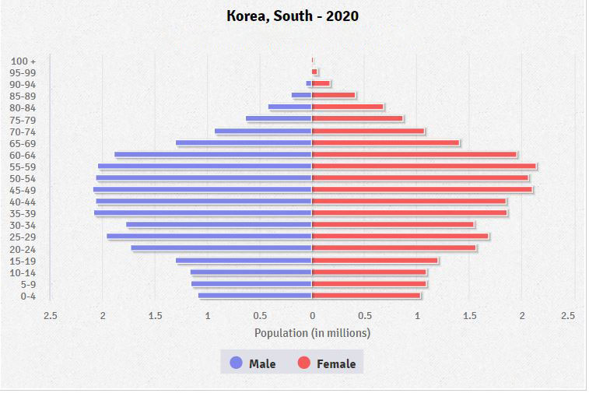
For example, the narrower bottom of the pyramid communicates a lower birth rate (The World Factbook, 2018). The pyramid becomes thicker as you go up, supporting its aging population and high life expectancy. The pyramid is also symmetrical, suggesting an equal proportion of males to females. Notice also the contracture at the bottom of the pyramid, characteristic of the 4th stage (Grover, 2014).
Epidemiologic transition in South Korea took place with fast industrialization, modernization, and urbanization. According to the pace of change, the epidemiological transition of South Korea is an accelerated model because it took about 35 to 40 years to achieve the Age of Degenerative and Man-made Disease. By 1970 the infectious diseases were replaced by the degenerative and man-mode diseases in the causes of morbidity and mortality. (Lee, 1982)
Health statistics
South Korea’s life expectancy, as referred to in the population pyramid above, is 79.7 years for males, 85.7 for females, and 82.627 years overall based on 2018 data. Infant and maternal mortality rates are quite low at 3 per 1,000 live births (2019) and 11 per 100,000 live births (2017) respectively (Republic of Korea - KOR). The annual number of under-five deaths in 2019 was 3.2 per 1,000 live births (Republic of Korea - KOR). The low infant mortality rate, maternal mortality rate, and the annual number of under-five deaths reflects South Korea’s high income status. This status is also reflected in the primary school enrollment ratio (2017) as it was 97.592% for males and 97.501% for females (Republic of Korea - KOR). South Korea is able to invest in the education of their children because of their high income status in the World Bank.
When it comes to the COVID 19 pandemic, South Korea’s statistics reflect that the country has not been hit particularly hard compared to countries such as the United States. South Korea only has 27,553 total cases and 480 deaths as of November 9th, 2020 (South Korea).
Burden of Disease and Risk Factors
When looking at the Global Burden of Disease Study DALYs graphic from 2019, the diseases/conditions that affect South Korea the most are: non-communicable, followed by injuries and communicable (IHME GBD Compare, 2019). Below is a chart synthesizing South Korea’s Burden of Disease based on the Global Burden of Disease Study data (regarding the whole population). It lays out the main causes of death and contributors to DALYs:

Figure 2
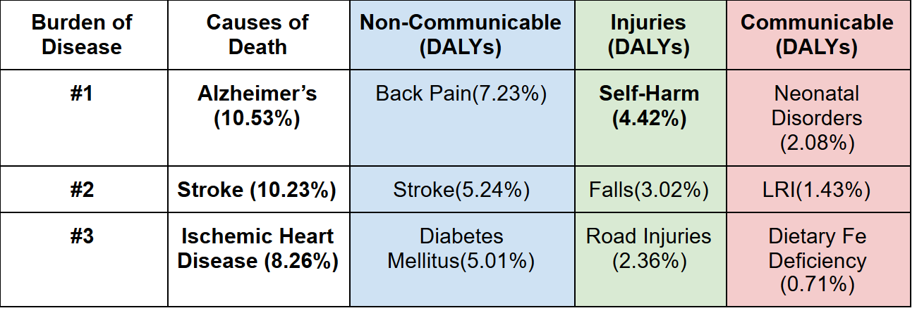
The following are 3 noteworthy observations according to the chart. First, South Korea’s burden of disease lies mainly in the noncommunicable diseases. Such is expected of a high-income country in a later demographic and epidemiological stage. Secondly, most of the illnesses/ conditions that bear the most weight are common to older populations, e.g. Alzheimer’s, back pain, and stroke. This makes sense with such a high life expectancy, as acknowledged in the Health Statistics section. Moreover, the prevalence of diabetes can be explained by the increased access to fast-food restaurants and the addiction to video games. Thirdly, South Korea, despite its robust economy and innovative healthcare system, suffers from self-harm. The mental health burden due to injury can be attributed in part to South Korea’s rigorous academic system. All the former observations point to South Korea’s later demographic transition, higher income/ development, and aging population.
Investigating and understanding risk factors gives one a clearer picture of South Korea’s burden of disease. Below is an important graphic obtained from IHME highlighting South Korea’s top risk factors as well as their percentage change from 2009-2019 (IHME, 2019):
Figure 3
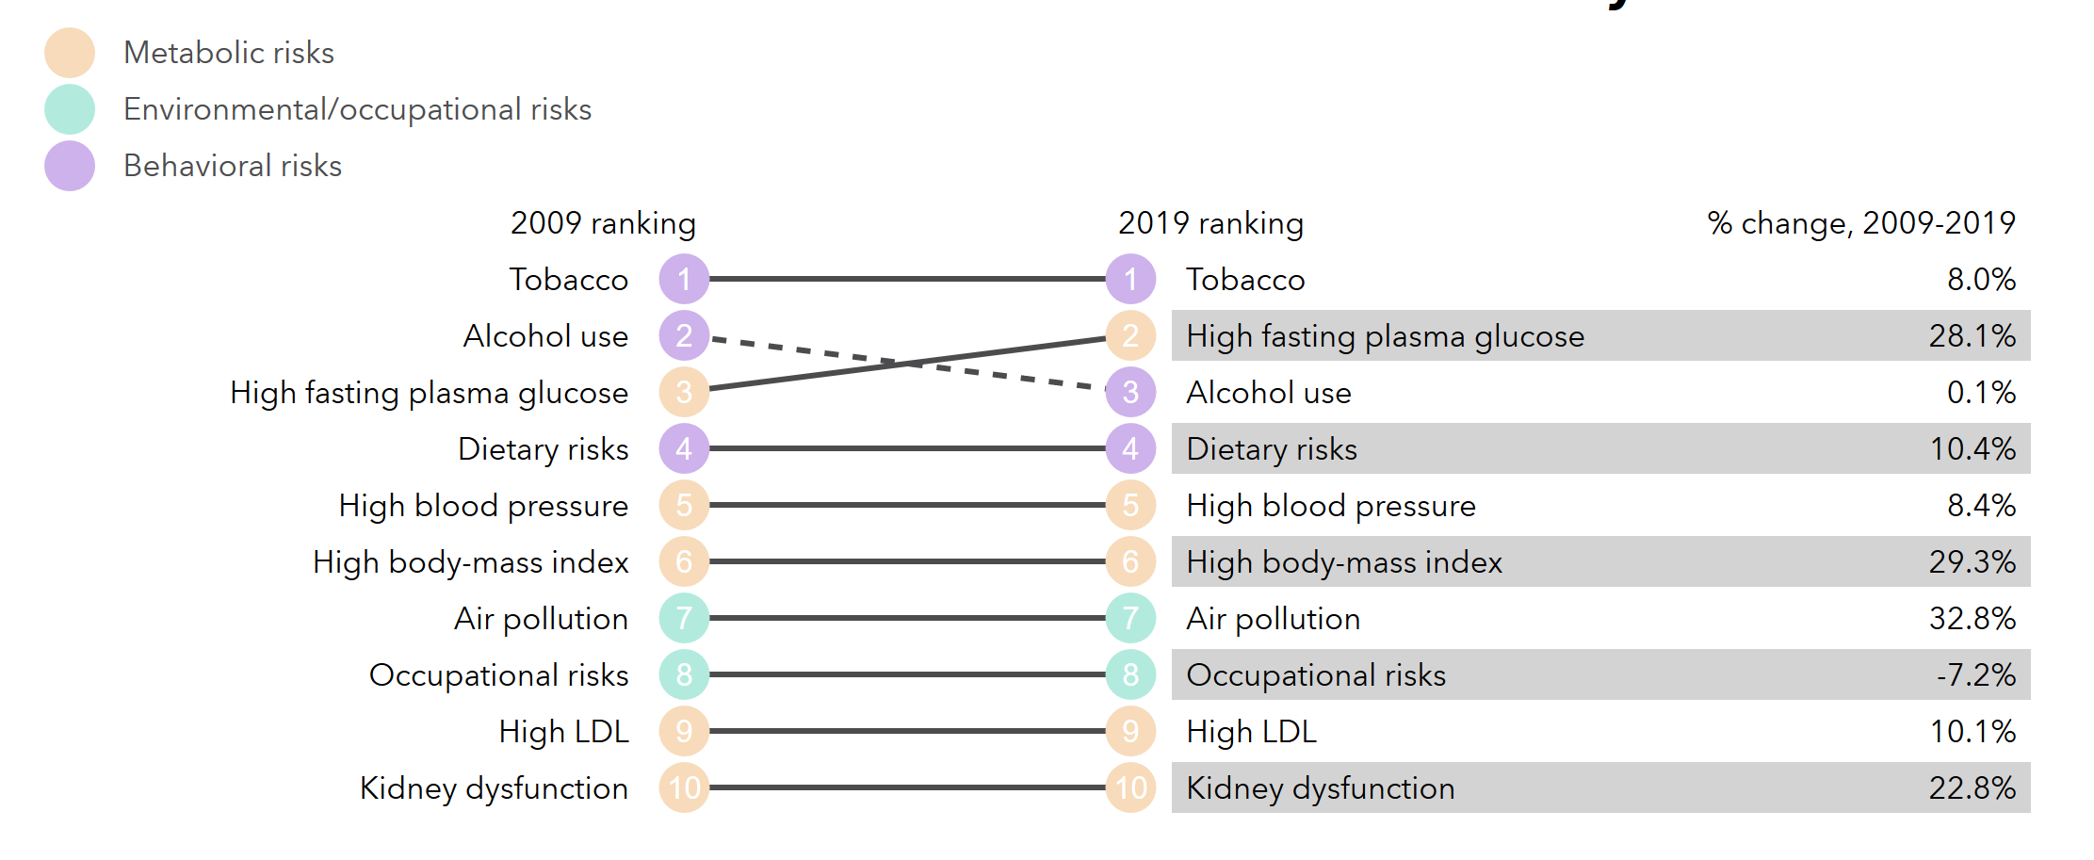
As seen in the graphic, Korea’s top ten risk factors, contributing to the total number of DALYs in 2009 and 2019, are metabolic, environmental, and behavioral. While half of the risk factors are metabolic, the more significant ones are behavioral. Specifically, 3 of the top 4 risk factors, i.e. tobacco (#1-2019), alcohol use (#3-2019), and dietary risks (#4-2019), are behavioral (IHME, 2019). In terms of percentage changes from 2009-2019, high fasting plasma glucose, high body mass index, and air pollution increased 28.1%. 29.3%, and 32.8%, respectively (IHME, 2019). The breakdown of South Korea’s risk factors further explain the underlying diabetes and mental health issues evident in its burden of disease.
Health system and health programs
The South Korean Ministry of Health and Welfare (MOHW) manages the country’s healthcare, in particular the National Health Insurance (NHI) system, which achieved universal health coverage for the population in 1989. The MOHW’s sub-entities serve to assess and regulate health care costs, manage the insurance system, reimburse providers, and regulate emerging technologies. The MOHW also provides health care through government owned regional and local medical facilities, but 94% of South Korea’s health care services through private sector hospitals and clinics (Kwon et. al., 2015, pp. 13-15). Regardless, all providers are required to provide the basic health package included under the NHI: “medical checkups, general procedures, accident coverage…[some] prescription medication,” and some dental care ("Health Insurance and the Healthcare System”; Kwon et. al., 2015, p. 40, 72).
The NHI coverage plan requires that all citizens sign up for the NHI via a single-payer system. The NHI is financed by the Social Health Insurance program, which requires South Koreans contribute an amount proportional to their income level to receive the insurance. Those with lower socioeconomic statuses are exempt and covered by the Medical Aid Program. By most recent data reports, the NHI covers only 60% of total health costs incurred by South Koreans (Osental, 2018) because the NHI imposes out-of-pocket payments (OOPs), which impose additional fees of varying degrees for health service use. For example, in-patient services require 20% of original cost OOPs, but various out-patient services cost upwards of 60% (Kwon et. al., 2015, pp. 41-42). There is a trend of rising OOPs that pose undue burden on the vulnerable, and thus the government has introduced reduced cost sharing initiatives for the elderly, young children, individuals with chronic illnesses, and those in poverty (Kwon et. al., 2015, p. 42). Regardless, health costs continue to rise, particularly due to demand for unregulated and expensive uninsured services provided by private facilities, resulting in an increased trend of private insurance plan purchases to manage health care costs (Kwon et. al., 2015, p. 43).
In terms of health programs, South Korea has been successful in managing CDs. However, its changing demography has created an increase in NCDs. Part of South Korea's success in dealing with CD’s is due to its National Immunization Program for “children under 12, adults over 65, and high risk populations,” and boasts high coverage completion rate for children under age 3 (Country Cooperation Strategy, 2019, p. 9). To tackle both CDs and NCDS, the government has implemented Nationwide Screening Programs that creates surveillance systems for emerging diseases and proactive health screenings for chronic illnesses, school children and employees (Kwon et. al., 2015, pp.61-62).
To directly address its aging population and their associated NCDs, long-term care programs were created to provide care for adults 65 and older that have ADL trouble and removes the burden of care off of families (Kwon et. al., 2015, p.70). To tackle NCDs as related to public behavior, MOHW engages in national public awareness programs and motivational communication campaigns to discourage communities from lifestyle risk factors that contribute to NCDs, which include smoking, alcohol abuse, lack of physical exercise and obesity (“Challenges & Tasks Ahead”; Country Cooperation Strategy, 2019, p. 10). Overall, South Korea is very successful with its health systems and health programs. However, there are still a lot of issues that need to be worked out to ensure a healthier and happier population.
Priorities in health
1. Address gaps in mental health: One of the health priorities of South Korea is to address the high suicide mortality rate. The suicide rate in South Korea is 29.1 per 100,000 population compared to 12.4 of the OECD countries. Suicide rates have doubled since 2000, and it is prevalent in men of the older category and teenagers. Besides, South Korea has a high prevalence of schizophrenia and bipolar disorders as well. (OECD, 2016)
2. Reduce alcohol and tobacco consumption: The distribution of alcohol drinking is concentrated in the population with low education. The heaviest drinking 20% of the population drink 66% of all alcohol. It is six times higher for a Korean average 40 years old man with a low educational level to engage in hazardous drinking than a Canadian citizen.
In 2013, 36.3% of male adults smoked in South Korea, which is 12 points higher than the OECD countries. One in five deaths among adults aged 30 or over is tobacco consumption, which is double that in countries of the Western Pacific region. (OECD, 2016)
3. Ensure a safe environment: Air pollution is a big concern for public health. In 2016, 31.2 premature deaths related to air pollution per 100 000 population occurred in 2016. Moreover, 2016 was the warmest year on record, and heat-related deaths have occurred due to unprecedented heatwaves. (WHO, 2019)
4. Overcome the demographic crisis: The low birthrates and aging population has created a distressing low age dependency ratio of 41%. The rapid decrease in the productive population represents a significant threat to the country's sustainability and puts pressure on public social welfare expenditures. Also, the increase in the senior population has increased degenerative dementia. In 2017, the aging population with degenerative dementia was ~725 000, and it is expected to exceed 1 million by 2024. (WHO, 2019).
5. Improve health care access: According to the OECD, South Korea has the highest out-of-pocket (OOP) payments, which is 1.7 times higher than the OECD average. The high OOP creates a barrier for those of low income to access medical care. (OECD, 2016)
6. Health Security and Emergencies: South Korea is a vulnerable country to infectious disease outbreaks due to high population density, high international traffic, and a high percentage of old populations that are not resilient. Therefore, Korea was the most impacted country by MERS in 2015. Since then, preparedness for epidemics and pandemics has been a priority for the country. The Framework Act on the Management of Disasters and Safety and the Infectious Disease Control and Prevention Act have been updated since then. The updates strengthened their response to the 2019 COVID pandemic by coordinating emergency response agencies, strengthening the infectious disease control system, reinforcing hospital regulation, and increasing the public health workforce. (OECD, 2020)
COVID-19 Response
In terms of COVID-19, South Korea was quite successful. Both the government and the people responded well and quickly in detection, containment, and treatment. To detect COVID-19, they opened 600 testing centers, administering 15-20,000 tests per day. After the peak of 209 cases in February, the number of new cases fell quickly and reached a steady state. In contrast to the U.S., South Korea followed a trace then quarantine model (with the help of epidemiological intelligence officers). Thus they did not close down businesses throughout the cities. Lastly, it expanded its healthcare system to provide treatment, e.g. temporary hospitals. Moreover, South Korea targeted clusters of cases, e.g. in Daegu, and educated the population about the virus (e.g. identifying the 7 groups of high risk). Some attribute such a rigorous response to the previously failed and poor response to the MERS outbreak.
Trend data, and expected future trends
South Korea is following a trend that we see across most of the developed world. Due to progress in women’s health, improvements in family planning, an increase in female education, and the improvement of contraceptive accessibility, the fertility rate is dropping. While change in rate year by year is very small, the declining trend in fertility rate in addition to improvements in medicine contribute to the country's growing elderly population. South Korea has the fastest growing elderly population in the world with an elderly population projected to triple in the next 40 years, which will result in the elderly making up 50% of the population (Korea, 2020). The growing elderly population and shrinking youth is raising concern about the lack of resources, particularly health services, for the aging population. The government is worrisome, unsure as to how they will handle the lack of resources to support a growing elderly population. Additionally to out pacing health services, Korean elders are facing major wealth disparities. The rapidly growing elderly population and shrinking youth seems to be out pacing the needs for the elderly. As of 2015 nearly half of the 65+ population live in poverty (Hu, 2015). The populus seeks unprecedented help from the government to help resolve this problem.
Recommendations
South Korea has come a long way in improving health outcomes of its populations, but as a high-income country entering the 4th stage of demographic transition, it must manage problems resulting from uneven population shifts, rise of NCDs, and population lifestyle changes. To tackle the looming demographic crisis, South Korea has to manage both the low fertility and a rapidly aging population. With the aging population, they need to address that the amount of elderly qualifying for long-term care programs and their associated costs are increasing. They can do this by increasing social service employment, further removing burden from families, and stimulating the economy (“Challenges & Tasks Ahead”). For fertility trends, the government needs to participate in indirect and people-centered policies to associate childbirth and parenting with happiness, which they can do by taking more responsibility for childbearing, and improving parental leave, childcare provisions, and work-life balance (“Challenges & Tasks Ahead”).
To address health inequities due to regional separation of health care options and rising OOPs, more cost-sharing protection can be provided for socioeconomically and regionally marginalized populations (Country Cooperation Strategy, 2019, p. 13-14). The next recommendation would be to address concerning mental health trends at the community level by de-stigmatization and integration of mental health into regular health care practices and make treatment readily accessible (Kwon et. al., 2015, p. 59). Finally, they should further challenge the NCD exacerbating lifestyle risk factors with more progressive policy change, add restrictive measures e.g. taxes, and support additional campaigns to raise cultural awareness (Country Cooperation Strategy, 2019, p. 14). Overall, South Korea has been doing great in managing its population’s health, but it needs to continue to provide pathways to mitigate issues relating to its rapidly aging population, decreasing fertility rates, health care inequities, mental health trends, and lifestyle factors impacting NCDs.

References
A. (2020, June 30). Emerging COVID-19 success story: South Korea learned the lessons of MERS. Retrieved November 02, 2020, from https://ourworldindata.org/covid-exemplar-south-korea
Clark, D. (2020). South Korea. Retrieved November 21, 2020, from https://www.scholastic.com/teachers/articles/teaching-content/south-korea/
Daily life and social customs. (n.d.). Retrieved from https://www.britannica.com/place/South-Korea/Daily-life-and-social-customs
GBD Compare. (2019). Retrieved November 02, 2020, from https://vizhub.healthdata.org/gbd-compare/
Gifford, C. (2019, October 10). Baby boom or bust: why South Korea is desperately trying to boost its birth rate. https://www.worldfinance.com/featured/baby-boom-or-bust-why-south-korea-is-desperately-trying-to-boost-its-birth-rate.
Grover, D. (2020, April 6). Stage 4 of the Demographic Transition Model. Population Education. https://populationeducation.org/stage-4-demographic-transition-model/
Health Insurance and the Healthcare System in South Korea Explained. Guide to Health Insurance and Healthcare System in South Korea | InterNations GO. (2020, March 20). https://www.internations.org/go/moving-to-south-korea/healthcare.
History.com Editors. (2018, February 02). South Korea. Retrieved from https://www.history.com/topics/korea/south-korea
Hu, E. (2015, April 10). A Forgotten Generation: Half Of South Korea's Elderly Live In Poverty. Retrieved November 21, 2020, from https://www.npr.org/sections/parallels/2015/04/10/398498496/a-forgotten-generation-half-of-s-koreas-elderly-live-in-poverty
Korea, Rep. . (n.d.). Retrieved November 21, 2020, from https://data.worldbank.org/country/korea-rep
Kwon, S., Lee, T.-J., & Kim , C.-yup. (2015). Republic of Korea Health System Review. World Health Organization. http://www.searo.who.int/entity/asia_pacific_observatory/publications/hits/hit_korea/en/.
Ministry of Health and welfare. Challenges & Tasks Ahead..Retrieved October 15th, from https://www.mohw.go.kr/eng/pl/pl0103.jsp?PAR_MENU_ID=1003&MENU_ID=100326
OECD (2016). Health policy in Korea, Retrieved October 15th, from https://www.oecd.org/korea/Health-Policy-in-Korea-April-2016.pdf
OECD. OECD Reviews of Public Health: Korea. Retrieved October 15th, from https://www.oecd.org/health/health-systems/OECD-Reviews-of-Public-Health-Korea-Assessment-and-recommendations.pdf
Osental, D. (2018, December 7). Private health insurance still booming in South Korea. Insurance Business. https://www.insurancebusinessmag.com/asia/news/breaking-news/private-health-insurance-still-booming-in-south-korea-118259.aspx.
Republic of Korea (KOR) - Demographics, Health & Infant Mortality. (2020, February 06). Retrieved from https://data.unicef.org/country/kor/
Song, Y. J. (2009). The South Korean Health Care System. International Medical Community, 52(3), 206–209. https://doi.org/10.18411/a-2017-023
South Korea: Economy. (n.d.). Retrieved November 04, 2020, from https://globaledge.msu.edu/countries/south-korea/economy
South Korea. (n.d.). Retrieved November 21, 2020, from https://www.heritage.org/index/country/southkorea?version=153
South Korea. (n.d.). Retrieved from https://www.worldometers.info/coronavirus/country/south-korea/
South Korea. (2017, September 19). Retrieved November 02, 2020, from http://www.healthdata.org/south-korea
The World Factbook: Korea, South. (2018, February 01). Retrieved November 02, 2020, from https://www.cia.gov/library/publications/the-world-factbook/geos/ks.html
World Health Organization. Republic of Korea-WHO Country Cooperation Strategy 2019-2023. Published on 2019. https://apps.who.int/iris/rest/bitstreams/1174701/retrieve

