Sarah Rizk
GEOL 1904: Ecosystem Ecology
Lab 11: Leaf Litter Decomposition
12/7/16

Leaf Litter Decomposition of Maple, Spruce, and Oak Species Using Soil Moisture

Abstract:
The goal of this experiment was to compare decomposition rates among three different tree species, the Red Oak, Norway Maple, and Norway Spruce. The decomposition occurs when organic substances are broken down into simpler matter by way of bacteria and fungi. We conducted the experiment by using two tests sites comprised of a wet/downhill site and a dry/uphill site. We utilized the litterbag technique to measure the decomposition. In doing this we made 18 mesh bags and double bagged them in order to minimize mass loss in the process of transportation. We originally weighed out 5 g of leaves for each bag, making 6 of Oak, 6 of Maple, and 6 of Spruce. We randomly placed the different mesh bags in the downhill, wet site of Panther Hollow after removing obvious ground debris from the site. In 6 weeks, we returned to the site and collected 3 bags from each tree species. We washed, dried, and measured the leaves. After 6 additional weeks, for a total of 12 weeks, we collected the remaining bags and washed, dried, and measured the leaves. This remaining mass subtracted from the original mass of 5 g, gave us our decomposition. We hypothesized that we would observe decomposition after both 6 weeks and 12 weeks, however our rate of decomposition would be slower than compared to the dry site. We also hypothesized that maple would decompose the slowest. Our rationale for this was the amount of lignin, soil moisture, and temperature in the site and species. By using p-values, graph comparisons, and ANOVA testing we determined that our hypothesis is partially correct. Overall, the wet site decomposed at a slower rate, though the difference between the dry and wet site was not significant. At our site, the maple decomposed the least. The oak and the spruce had similar decomposition rates.

Introduction:
This experiment was conducted in order to compare decomposition rates among Red Oak, Norway Maple, and Norway Spruce trees in Panther Hollow. During observation of the project, we asked ourselves two different research questions:
- How does plant species affect the rate of litter decomposition?
- How does soil moisture affect litter composition rates?
We distributed the three different leaf species in wet and dry site areas in order to test these questions. When beginning the experiment, we determined the wet site has a soil temperature of 21.6 degrees F and a moisture level of 0.0798 m³ water/m³ soil. In general, some of the main factors influencing litter decomposition are biological activity, oxygen levels, soil pH, moisture levels, and temperature. In this particular experiment, due to our testing of a downhill/wet site, the most important factors are soil temperature (degrees F) and moisture level (m³ of water/ m³ of soil). We discovered in our research that excess water content in the soil slows the rate of decomposition because it decreases the amount of oxygen by filling in the openings in the soil with water, rather than oxygen. The decrease in oxygen leads to a lack of needed oxygen for microbes in the soil. Also, we discovered that the warmer the temperature of soil, the faster the rate of decomposition among the organic matter because of microbial activity in the soil. The soil at our site was measured to be 21.6 degrees F, which is lower than the temperature of 40 degrees F that is required to have microbial activity. Therefore, we again concluded that our decomposition rate would be slower because of our colder temperatures. Our hypothesis is as states, we predict that there will be leaf litter decomposition after 6 and after 12 weeks, though it will occur at a slower rate than at the dry sites.

Methods:
In part I of methods, we discuss the materials and methods in the field and lab procedures and in part II of methods, we discuss the appropriate statistical analysis and graphing.
We originally weighed 5 grams of leaves for each of the tree species. We then used the leaf litter technique, a highly utilized method of measuring leaf litter decomposition. There were 6 bags for each kind of species, resulting in a total of 18 bags mesh leaf litter bags. We used mesh in order to allow for the decomposition to occur and we double bagged them in hopes to decrease the amount of mass lost in transport. There were also test bags for each species in order to measure the mass potentially lost in transit. Once the bags were made and 5 grams of leaves were placed in each bag, we went to Panther Hollow. In order to allow for the proper decomposition, we cleared obvious surface debris from the wet/downhill site and randomly distributed the leaf litter bags, marking them with orange flags for easy identification later. After 6 weeks we picked three bags from each species, resulting in 9 total bags. We washed the leaves in order to remove excess dirt and mud so it didn’t influence the final mass. After allowing the leaves to dry, we weighed them to find the amount of decomposition after 6 weeks. We repeated this process after an additional 6 weeks for the remaining 9 bags.
In order to look at the influence of multiple factors, we conducted an ANOVA test. This measures the trends in decay for the three tree species. We also included error bars in order to show the variability and overlap in error. The second test we ran determined the p-values of the data in order to determine the significance of our data. A value under .05 shows that the data would be statistically insignificant. After running statistical tests, we graphed that data to show trends. The first graph we created looked at the wet data we collected at our site. The second graph showed the wet data vs. the dry data that we collected in the experiment in order to graph the importance of soil moisture.
Results:
Overall, our data showed a decline in mass for all 3 leaf types. Oak declined the most over a 12-week period. Occasionally, the mass increased, likely due to the accumulation of sediment because our leaf litter bags were in high moisture areas with heavy levels of mud and
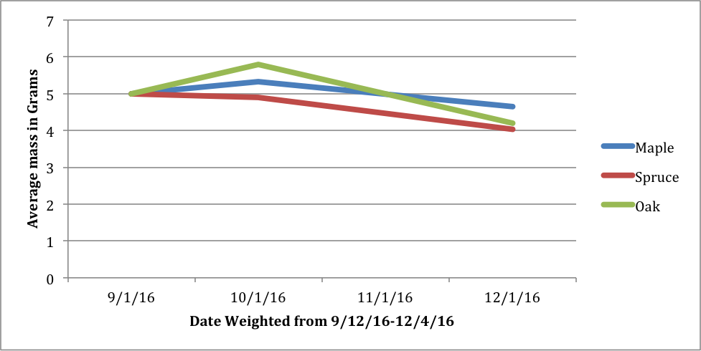
dirt. The biggest decrease of mass we saw was in the spruce species of 1.5mm. The maple leaves decayed the slowest in both the wet and dry areas.
Decomposition of Leaf Species at Wet Site

Figure 1: This graph shows the decomposition of data from our wet/downhill site of the three leaf species. The graph shows that Spruce decomposed the most and that Maple decomposed the least. The slight increases in mass after 12 weeks is most likely due to an accumulation in sediment.

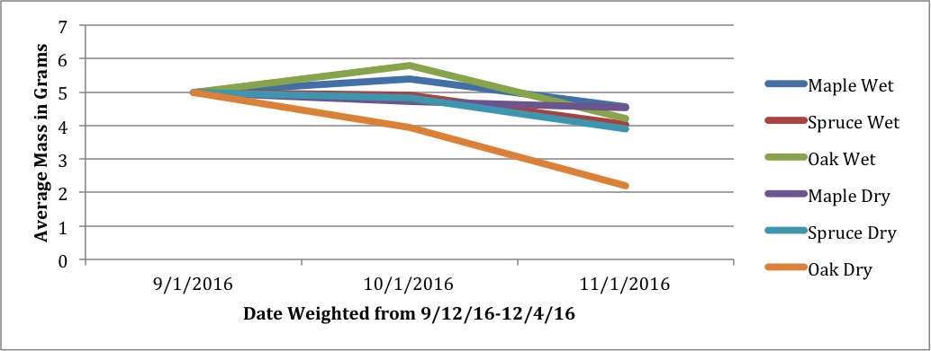
Decomposition of Species at Wet and Dry Sites
Figure 2: This graph shows the decomposition of data from the complied wet and dry sites. The graph shows the decomposition rates for the Spruce and maple at the wet and dry sites were very similar. This suggests that there is not a significant difference in decomposition rates between the two sites, with the exception of oak, which decomposed much more at the dry site. Overall, the wet site decomposed slower.

We used ANOVA testing to measure the trends in decay for the three leaf species. As shown in the graph, there are different averages of lost mass for the three species. However, the overlapping of the standard error in the Oak and Spruce species suggest similar decay rates between the two species.

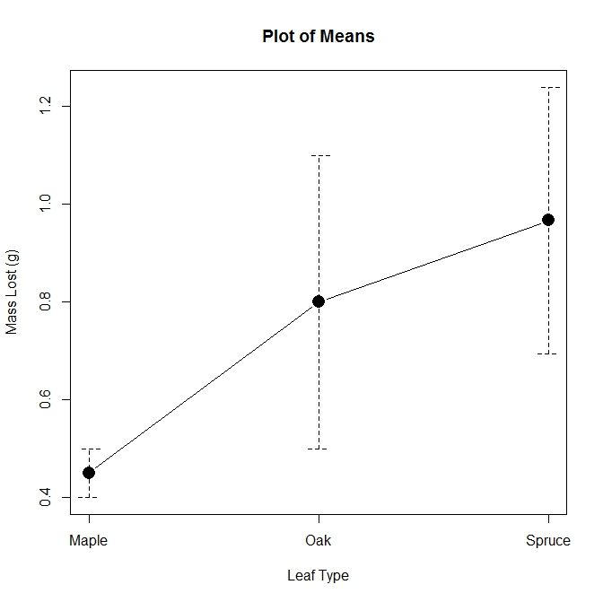

Then, after performing a statistical paired T-test, we found the p values for our data. Our data measured the change in mass after 12 weeks for wet vs. dry leaves. A p value under .05 shows that data is statistically significant. Our p-values are as follows:
Oak: .1756
Spruce: .7153
Maple: .8088

However, because our p values are larger than .05, our data indicates that it is not significant. If the p-value is less than .05 then you reject the null hypothesis but if it is greater you accept the null hypothesis, therefore we accept the null hypothesis.

Discussion and Conclusion:
We have discovered through statistical analysis and graphs that our hypothesis is partially correct. We believed the wet site would decompose at a slower rate, and overall it did show signs of slower decomposition. This is shown by the graph comparing the data from the wet and dry sites, specifically of the Oak species. However, according to our p-values from the t-test, which do exceed .05, the difference between the two sites was not statistically significant. Between the three species, it can be clearly shown that maple decomposed the least, and spruce and oak had a large overlap of error, outlining the similar decomposition rates. There were multiple sources of error that may have influenced our decomposition measurements. The first being the rise of mass after 12 weeks in some species which can potentially be contributed to excess mud we were not able to remove during washing and microbial activity. We also thought it was worth knowing noting that data could be skewed due a loss of mass in washing and transport, specifically of the spruce needles. As with any field work, risks are involved in leaving data outside. When we went to collect our data, we found out that we had lost two of our leaf litter bags. With a loss of samples, comes with an incomplete data set also skewing our data. In conclusion, our hypothesis was partially correct. Although our leaves did decompose and they did show to be at decomposing at a slower rate than the dry site on the graph, the ANOVA tests and p-values showed that the data could be interpreted as statistically insignificant. This can be shown in every groups data. Other similarities include both wet and dry Maple leaves decomposed the slowest, possibly in contribution to their lignin content. Ultimately, we decided that soil moisture and leaf type does influence decomposition rates to some extent, however more testing would need to be done in order to verify that and dispute the statistically insignificant data. We also acknowledge that to see decomposition fully, a longer testing period would be required. In general, without human interaction, decomposition can take up to two years. This could explain why we had begun to see trends, however our data was still considered statistically insignificant.

Works Referenced and Acknowledgements:
"Factors That Influence the Decomposition Rate of Organic Matter in the Soil." Home Guides | SF Gate. SFGate, n.d. Web. 04 Dec. 2016
Richard, Tom. "The Effect of Lignin on Biodegradability - Cornell Composting." The Effect of Lignin on Biodegradability - Cornell Composting. Web. 01 Dec. 2016.
Yoon, Tae K., et al. "Soil Moisture Effects on Leaf Litter Decomposition and Soil Carbon Dioxide Efflux in Wetland and Upland Forests." Soil Science Society of America Journal, vol. 78, no. 5, 2014., pp. 1804doi:10.2136/sssaj2014.03.0094.

I worked with Christy Koerner and Stephanie Kambic to conduct this lab.

