Noah Coco
ECON 1720
7 December 2018
Infrastructure Investments: Irrational Behavior in the Belt and Road Initiative
China’s rapid domestic economic growth has propelled the country into the global economic system. As economic growth begins to push the limits of domestic capacity, government officials and industrial leaders are seeking commercial opportunities overseas. The globalization of China’s economic interests has been partially engendered by the recently announced Belt and Road Initiative (BRI), a massive international geopolitical and economic development strategy. The BRI proposes a global network of infrastructure investments spanning from Eurasia to Africa as part of China’s global strategy of becoming a leader in economic integration. Thousands of miles of roads and railways have been proposed and constructed, as well as ports, power plants, and other infrastructure projects. Although these projects carry the potential for tremendous benefits, there is extreme risk involved. This risk is rendered much more acute when considering the massive scale of the entire endeavor. However, the political and economic aspirations motivating these investments from within China obscure this tremendous risk. In particular, the political ambitions of President Xi Jinping and the Chinese Communist Party promulgate irrational economic behavior driven by a desire for both economic and political returns.
The purpose of this paper is to use a political economy model of infrastructure investment to demonstrate that irrational economic behavior motivated by political justifications is conducted in the context of the Belt and Road Initiative. This paper will begin with a brief background on the BRI. That will be followed by a discussion of the theory of political economy models of infrastructure development and the political motivations that encourage irrational economic activity. This framework of political economy theory will then be used to contextualize the Belt and Road Initiative, which will include an analysis of its distinct characteristics. The first characteristic that will be discussed is the behavior of national policy banks in implementing government strategy. The second characteristic is the hasty and unregulated approval process for BRI projects and the political justifications that motivate it. The third characteristic that will be discussed is the assessment of risk in developing countries and how political motivations lead to miscalculations about the true risk involved. The paper will then finish with concluding remarks.
The Belt and Road Initiative – initially named One Belt One Road – is an international infrastructure investment strategy announced in 2013 by Xi Jinping, President of the People’s Republic of China and General Secretary of the Chinese Communist Party. The BRI is touted as a development strategy and proposes a global infrastructure network that integrates developed and less developed nations across Eurasia and Africa. Projects under the BRI label span across Asia, Africa, and Europe. They predominantly constitute two overarching routes, the Silk Road Economic Belt by land and the 21st Century Maritime Silk Road by sea. The types of projects pursued under the BRI cover a variety of sectors including: energy and power, transportation and telecommunications, rural infrastructure and agriculture development, water supply and sanitation, urban development, and logistics.
The BRI has roots in China’s “Going Out” policy, which was inaugurated by President Jiang Zemin in 1999 (Kong and Gallagher, 2017). The policy encouraged individuals and firms to expand their international commercial interests and promote overseas investments. Chinese economic actors have taken advantage of this policy to expand their operations through foreign direct investment and foreign asset acquisition across the globe. Much of this outward expansion of capital over the past few decades has been funded by Chinese policy banks like the Agricultural Development Bank of China, the China Development Bank, and the Export-Import Bank of China. These policy banks implement government initiatives by supplying funding to entities like large state-owned commercial banks and state-owned enterprises (SOEs). They provide cheap sources of credit for firms to access to fund their ambitions abroad while allocating China’s extensive holdings of foreign exchange reserves.
The BRI is an updated and directed specification of the general “Going Out” policy that has been a feature of Chinese commercial and investment activity in the past couple decades. It is a more focused policy that directs resources towards geopolitical goals. It also seeks to address the $1.7 trillion annual world infrastructure financing gap by utilizing domestic Chinese overcapacity abroad (HSBC, 2018). In sum, the initiative seeks to establish China as a world leader in global trade and connectivity. The political motivations of this endeavor must be stressed just as much as the economic considerations. The BRI should be understood as a geopolitical project just as much as it is considered an economic development strategy. The political agenda that drives the BRI comes predominantly from Chinese President Xi Jinping and his personal ambitions. Xi Jinping intends to bolster his domestic political power while also projecting this international power across the globe. He wishes to establish himself as a global leader that oversees the economic integration of 60% of the world’s population and 30% of its output in the BRI territory. He even enshrined the BRI in China’s constitution, giving it a heightened political imperative (Joy-Perez and Scissors, 2018).
The success of the BRI also has political consequences for the Chinese Communist Party, who have a political imperative of maintaining economic growth and high employment. With a saturated domestic market that already deals with overcapacity in several sectors, the BRI provides an opportunity for firms to expand their activities beyond domestic markets. This also provides additional sources of employment and national income for Chinese workers. Xi Jinping is similarly motivated by these party prerogatives, but he is also motivated by the personal ambition of staking his reputation on the success of the BRI. It holds the potential to be his most significant achievement as President and General Secretary, so he has strong interests in promoting its implementation. Because the BRI has a direct impact on the power and political future of Xi Jinping, he and the Chinese Communist Party have a further incentive to promote its success. The political justifications for this project, however, may actually contribute to the project’s demise. Political motivations for investments obscure the economic reasoning that should justify financing projects. As a consequence, BRI infrastructure projects are often proposed that are redundant and do not address sound economic reasoning.
In order to analyze the impact of political motivations on economic decision-making within the context of the BRI, this paper will adopt a political economy framework of infrastructure investment. Aschauer (1988) first examined the theories of public finance to derive a political economy model of infrastructure investment. He argues that public investment increases the rate of return to private capital and stimulates private investment expenditure. Public finance often fills the investment gap that is left by private actors. One reason that private actors may be unwilling to engage in these investments is because they may not offer a high enough rate of return to justify allocating capital to these projects. There would be a high opportunity cost of making these investments over projects with more favorable returns. A second explanation is that the investment may not be appropriable, meaning there is no effective method of excluding other agents from consuming or benefiting from the investment. This challenges the ability for firms to charge and receive a price for the consumption by some agents. A third explanation utilizes an economy of scale argument. This argument suggests that some projects require such a high scale of production that it is only practical for the government to assume this responsibility and form a natural monopoly. This is the case for many water infrastructure systems, for example. Aschauer’s empirical evidence supports these theories. Using annual data from the period 1949-1985 he found that a “core infrastructure” that can include “streets, highways, airports, electrical and gas facilities, mass transit, water systems, and sewers” contributes to increases in productivity for private firms. This conclusion suggests that public investments have a substantial role in making private capital more productive and stimulating real economic growth.
Aschauer’s work sparked intense interest in the study of public infrastructure investment decisions. Cadot et al. (2005) provide an insightful qualification on this original theory that challenges its conclusions. In modeling investment decision-making, they do not assume that investment decisions are based on maximizing social welfare. Instead they model the decision-making process using office-motivated politicians, probabilistic voting, and influence activities (lobbying). By doing this they orient the public investment decision-making process within a political economy framework. The authors test for the role of lobbying in investment decisions and find that public goods are used as “redistribution instruments” by politicians. The logic behind these findings is that lobbying activities conducted by private agents influence incumbent politicians. The politicians exchange financial support from lobbying groups – used to achieve further political gains in the electoral process – for allocating favorable infrastructure investments. What is particularly revealing about their results is that the coefficient on the productivity variable in their regression was insignificant, which suggests that investment decisions are not based on maximizing marginal product. In sum, “roads and railways are not built to reduce traffic jams: they are built essentially to get politicians elected.”
Evidence of political interferences in the public infrastructure investment decision-making process has been replicated in numerous other studies. Solé-Ollé (2013) concludes that “tactical redistribution” partially influences regional allocation of public capital investment in Spanish electoral districts. Solé-Ollé defines “tactical redistribution” as synonymous with “pork barrel influences” – which is consistent with Cadot et al. (2005) – and finds that districts that are most “politically productive” receive higher quantities of investments. Kemmerling and Stephan (2015) analyze the role of political institutions, federalism, and the electoral system in regional public infrastructure investments in France, Germany, Italy, and Spain. They find consistent results across relatively diverse political systems that partisan politics are influential in determining the distribution of regional transport investment. In another study, Worthington and Dollery (1998) model Australian intergovernmental grants by including public finance and public choice influences on distribution decisions. They conclude that “grants are used by federal government politicians to purchase political capital, thereby enhancing their own chances of reelection.” Although they do not examine public infrastructure investment, the decision-making logic is consistent with the previous studies. These studies all identify the phenomenon by which political leaders use discretionary public finance decisions for political gains.
The previous studies provide the political economy theory to analyze BRI investment decisions. There is one important factor, however, that distinguishes BRI investment and the public investment decisions of the previous models. Whereas the previous studies considered political economy on a national domestic level, the BRI is an international development project. However, the more fundament results from the studies concern the decision-making process for discretionary public finance, and in this respect the results are relevant in the BRI context. The BRI is characterized by Chinese government officials using political motivations to justify investment decisions. The difference is that the political rewards are received from international actors primarily consisting of nation states. The BRI, conceived as a geopolitical strategy, is a valuable tool of soft power and a demonstration of economic might. Xi Jinping intends to garner international recognition and political power by investing in projects that aid in the economic development of developing countries. Consideration for the returns on these investments go beyond economic returns to include political returns as well.
Within the context of the BRI there are three ways in which motivations for political gains interfere with rational economic decision-making. The first source of political justifications for irrational economic decision-making is cheap credit offered through China’s several policy banks. The second source is the hasty and relatively unregulated review process for proposed BRI projects and investments. The third and most substantial source of political interference is in the risk assessment of projects in developing countries. This paper will proceed by examining each of these sources of political interference in economic decision-making and relating them to the political economy model articulated above.
The first manner in which political motivations obscure optimal economic decision-making in the context of the BRI is the cheap credit that is offered by policy banks to state-owned enterprises. The primary policy banks that are active in financing the BRI are the Asian Development Bank, the Asian Infrastructure Investment Bank, the China Development Bank, and the Silk Road Fund, a $40 billion fund – later many more billions were added – that was created in 2013 to complement the announcement of the BRI (HSBC, 2018). These policy banks exist to implement government directives and priorities from the CCP and effectively serve as the “financial arms of the state” (Kong and Gallagher, 2017). This means that Xi Jinping’s promotion of the Belt and Road Initiative influences the allocation of financing towards BRI projects. Furthermore, according to Kong and Gallagher, these policy banks globalize Chinese capital, promote the country’s exports, and provide opportunities for Chinese firms and workers to acquire more technical skills through investments and construction. These functions satisfy the other political imperative of promoting employment and growth in the domestic economy. These features both adequately demonstrate that political reasoning influences investment decisions under the BRI label. Investment decisions are not fully assessed for their risk and possible economic returns but for their adherence to national strategy, which is informed by political motivations for political returns. This is consistent with the political economy model adopted in this paper. Xi Jinping and the CCP are motivated by their political reputations in promoting the BRI, and the policy banks are one method of implementing their political ambitions. However, there are other features of this mechanism that reveal even more characteristics of political interference in economic decision-making.
Policy bank funds are allocated primarily, but not exclusively, to SOEs, which are not efficiently managed firms. SOEs are fundamentally not profit-seeking. They are, as the name suggests, backed by the central government. This means that SOEs also are not at risk of bankruptcy because they can rely on the inexpensive financing from the state-directed policy banks (Joy-Perez and Scissors, 2018a). The institutional structure of SOEs suggests that they are not operated using the same set of incentives as private firms, and so they are not incentivized to maximize economic returns. This makes them ideal tools to implement government directives, and the data reflecting firm involvement in BRI investment projects reflects this. Figure 1 depicts the total quantity of investments made by SOEs and private firms, both inside and outside of the BRI from 2014-2017. The data shows that SOEs dominated financing in both categories compared to private firms. Within the BRI, SOEs represented more than twice as much investment as private firms. This suggests that massive amounts of BRI investments are allocated by policy banks and distributed to SOEs, who are also designed to implement government policy. The political interference at each stage of this allocation process obscures the economic reasoning that should be informing investment decisions.
To demonstrate this point, if BRI investments provided sufficient economic returns, then rational economic decision-making would lead more private firms to choose these investments. As Figure 1 and Figure 2 demonstrate, private firms are choosing to invest in opportunities outside the BRI because they represent higher rates of return. The 2017 increase in private share of investments within the BRI reflects a response by private firms to a regulation passed by the central government that restricted property and entertainment acquisitions by private firms (Joy-Perez and Scissors, 2018b). This was done in an effort to encourage private firms to invest more in BRI projects. It is concerning that the Chinese government resorted to using alternative policy measures to incentivize private firms to invest in less profitable projects. For now, private firms are limiting their investments to relatively safe and stable BRI countries like South Korea, Singapore, and Israel. However, the political significance the BRI has for Xi Jinping and the CCP suggests they may employ more coercive measures to enforce compliance with the government initiative in the future. These actions would still remain consistent with the political economy model of infrastructure investment, but they represent a more heavy-handed enforcement mechanism to guide investment decisions to generate political returns.
The final feature of policy banks that will be discussed is the massive scale of their operations that are primarily funded by China’s holdings of foreign reserve assets. As was discussed earlier, policy banks distribute financing to SOEs for investment projects that private firms are unwilling to pursue themselves. This is not necessarily unusual since this is often the reason that development banks exist at all. Moreover, Kong and Gallagher’s (2017) study suggests that interest rates from Chinese policy banks are set at similar levels to their western counterparts like the World Bank or IMF. However, what is notable about China’s efforts is the scale of their investments across all their policy and development banks. For example, Kong and Gallagher found that Chinese policy bank allocations to the worldwide energy sector accounted for more than 50% of the world’s total quantity of financing. Figure 3 shows the yearly total value of investments and construction projects in BRI countries. This quantity has consistently increased since 2010 with large increases beginning in 2014. It is anticipated that keeping current trends constant, this quantity will reach $1 trillion by about the year 2024.
Much of the funding for these investments have come from China’s foreign reserve assets which it has been accumulating over the previous few decades. Figure 4 shows the yearly changes in foreign reserve assets. The data shows a sharp decline beginning in 2014, representing a net outflow of reserves. In total quantity, China held about $4 trillion in reserves at its peak in 2014, before steadily declining to about $3 trillion by 2017. This rapid decline in reserves challenges the ability of policy banks to implement further BRI investments. China’s foreign reserves diminished following the expansion of BRI investments and covering the losses of SOE firms that were not realizing returns from their investments. If this trend continues China will run out of funds to allocate to BRI projects. This challenge may have many possible outcomes, but one is that Xi Jinping will roll back on his original ambitions. This seems unlikely because of the significant political stakes of the BRI for his power domestically and internationally. Another possible outcome is that Chinese leaders will seek funding from other sources, like the private sector. Officials could coerce private firms to invest in BRI projects or create a regulatory system that incentivizes these investments. This would be damaging to the economy because of the opportunity costs involved and the possibility for low returns that might even deteriorate into negative returns on investments under this high risk. The potential costs of the BRI are very high considering the hundreds of billions of dollars in financing already in the BRI. Exposure to this risk at this scale has been motivated by political interference in the infrastructure investment decision-making process.
The second manner in which political motivations have manifested in the economic sphere is in the approval process of BRI projects. Projects are often subjected to hasty approval processes if they carry the BRI label. This removes a layer of oversight that would normally prevent funds from being used for unsound economic investments. There are both economic and political justifications for the reality that infrastructure projects that are labelled under the Belt and Road Initiative are subject to a hasty political approval process (Brinza, 2017). One of the economic justifications cites the overcapacity that the BRI is intended to ameliorate (Landry 2018). One of the consequences of China’s rapid industrialization is that state-supported industries like steel and cement have been overproducing. One of the primary motivations of this state-led industrialization was to keep the prices of these products low to expand exports and to keep workers employed. However, now that the major stage of industrialization is over, China is shifting away from this model of development but is still left with its structure. The logic is that approving a project will facilitate resolving this overcapacity without much necessary review. One of the motivations behind the BRI is to utilize the industries that have been overproducing and to facilitate exporting the products to new markets. China needs the BRI infrastructure transportation routes to deliver products to these markets more effectively. Although this is an economic justification for the BRI, it still does not consider calculations of expected returns on specific projects. Instead, it addresses the effects of market distortions from previous state manipulation of industries. Therefore, at its core it is still a political decision to resolve issues from previous economic policies that were, themselves, motivated by political goals of the Chinese government.
The predominant political interference that promulgates this lack of oversight is rooted in the political ambitions of Xi Jinping (Brinza, 2017). Because of the political significance of the BRI, projects are not subjected to thorough review because they promote Xi Jinping’s agenda. There is less incentive to thoroughly assess new projects when the politicians care more about expansion of the BRI than its economic feasibility. One context in which this process has become evident is at the local level with lower-level political leaders. Leaders are promoted to higher and more powerful posts on the grounds of merit, and the completion of a BRI project carries tremendous political clout. This encourages lower-level political leaders to pursue projects regardless of potential returns and sound economic reasoning. As Brinza (2017) argues, “size, not proﬁtability, is a priority.”
One way that this phenomenon has become apparent is in the construction of railways connecting Chinese cities directly to European cities. Many of these lines carry no economic purpose and yield very little profit, but new railway lines continue to be announced that connect Chinese cities to London, Duisburg, Budapest, among others (Brinza, 2017). It is not uncommon for these railway lines to be utilized at only about 50% capacity; cheap exports are shipped to European cities, but European goods are, in most cases, not imported back to China. The railway lines are redundant and most often operate at a loss because they are underutilized. They are then subsidized by local government subsidies, often ranging between $3500-$4000 per 20-foot container per trip. These investments are justified by political reasoning, but this obscures the economic rationale that would suggest against building additional lines in many of these settings. It is evident from this case study that unprofitable investments are being encouraged to satisfy political motivations, and the quantity of these projects is relentlessly increasing.
The third manner in which political motivations interfere with economic decision-making regards the assessment of risk in the implementation of infrastructure projects in less-developed countries. This point is related to the previous point about investing in unprofitable projects like railway lines that connect with Europe that go underutilized. Although there is significant loss, the losses can be relatively well predicted because of the maturity of many of the economies that these railway lines connect to; there is less risk associated with these investments. Even though they represent significant opportunity costs, these costs are taken on by the government to support its political prerogatives. The risk that is associated with developing nations is much more severe and uncertain, and it carries the potential for unanticipated investment failures.
Many developing countries across Asia and Africa represent tremendously risky investment opportunities. However, these locations are also the primary destinations for BRI projects. What makes the relationship between China and BRI countries problematic is that BRI countries are often eager to secure any form of funding that is offered to fuel development, while China is politically motivated to pursue investments in these risky countries. The sovereign credit ratings for developing BRI countries do, in fact, reveal a broad spectrum of risk. Although many needed infrastructure investment projects located within developing countries fall within the investment grade (about 49% of financing), a large percentage are considered speculative grade (about 35%), while a smaller but still significant percentage are not given any rating at all (16%) (Liu et al., 2016). Alternatively, Hurley et al. (2018) examine the debt vulnerabilities of Belt and Road countries and identify 23 countries that are highly vulnerable to debt distress from a distribution of BRI countries that is depicted in Figure 5. Of these countries they identify 8 that are particularly exposed to debt distress from BRI financing demands based off rising debt-to-GDP ratios beyond 50-60%. These countries include: Mongolia, Montenegro, Pakistan, Maldives, Djibouti, Laos, Kyrgyz Republic, and Tajikistan. However, a number of other countries that are just below that threshold are experiencing concerning increases of debt owed to China from BRI financing that could lead to debt distress and default under deteriorating economic conditions. These countries include: Egypt, Ethiopia, Ukraine, Cambodia, Afghanistan, Jordan, Kenya, Belarus, Armenia, among others. The fate of these countries will largely depend on their ability to translate BRI projects into sustained real growth without slipping further into debt burdens.
These ratings reveal the tremendous risk involved in investing in developing countries. This risk derives from numerous factors spanning from violence and political turmoil, to economic backwardness and social unrest, to environmental impacts, among others. It is difficult to accurately assess these risks, making it – conversely – very easy to miscalculate the true underlying risk of investment opportunities. As Parameswaran (2017) argues, these risks present structural challenges to China’s BRI investments throughout Eurasia and Africa. Unsustainable debt, lax social and environmental regulations, among other factors in overly risky projects often lead to massive unexpected losses, or at the least very limited success. In fact, various unpredictable factors can indefinitely delay a project to the point where construction does not even begin before it is abandoned. Arduino and Gong (2018) qualify similar security and risk challenges to successful implementation of the BRI. The security challenges include ethnic and religious tensions by local populations, lack of legal protections, uncertainties about local regulations, criminal or terrorist violence, or environmental degradation. Many of these factors create political risk to be considered when assessing investment opportunities. Arduino and Gong also reiterate Parameswaran’s (2017) argument that unsustainable debt or lax social and environmental standards provide additional risks that must be accounted for.
With all of these risk factors articulated, it is much clearer to see the potential for the miscalculation of risk. However, there are still other factors that can exaggerate this miscalculation. The first factor is the inexperience of many actors engaging in BRI infrastructure projects (Joy-Perez and Scissors, 2018a). Although firms may have expertise in their domestic industry, this knowledge does not translate well to international settings. It is often the case that construction firms seek investments abroad in countries where they do not have an established presence. This lack of local knowledge makes risk assessment even more difficult for Chinese individuals and firms. When this lack of experience and knowledge is complemented by easy credit from policy banks and a hasty approval process with little oversight, the potential for misallocation of resources in these speculative activities could contribute to substantial losses. The final factor that is relevant in miscalculating risk is the political motivations behind the infrastructure investment decision-making process, the central thesis of this paper. Because Chinese actors are motivated by political returns for their investments, this reasoning obscures the underlying risks associated with these projects. The resulting behavior is irrational and vulnerable to significant losses if multiple overly risky investments default.
The consequences of this speculative activity have already been witnessed in several contexts that reveal the broad extent of leverage of Chinese economic actors backed by the government. There have already been two notable examples of countries that have experienced debt distress over BRI projects. The first example is a relatively small case study in Sri Lanka. Despite negative feasibility studies, rejections from other lenders, and rapidly inflating debt, China offered loans for construction of the Port Hambantota. When the Sri Lankan government, burdened by debt, could not afford to continue making payments on this Chinese BRI project, it was forced into negotiations to give up ownership of this newly constructed port for 99 years (Abi-Habib, 2018). The second example is quite more substantial. Pakistan is experiencing extreme debt distress from financing of BRI projects throughout the country. Pakistan is a crucial location for China because it serves as the primary conduit through South Asia around India. Billions of dollars of investments have been allocated to Pakistan, which reflects its strategic interests for China. However, the conflict between political and economic interests is evident since Pakistan, an unstable developing country, has been unable to make its payments in the face of rising debt and internal economic and political instability. Pakistan has fallen into risk of defaulting on its financial obligations to China, and has requested assistance from the IMF for a bailout, its second request since 2013 (Lawder, 2018). These examples reveal the inherent and often unaccounted for risks that are associated with developing countries, and they demonstrate that they are not just hypothetical risks but actual risks that have already threatened China’s BRI interests in the country.
The confluence of the factors discussed above create a situation in which desire for political gains leads to irrational economic decision-making. Similar to the political economy model of infrastructure investment discussed earlier in this paper, political pressures interfere at various stages to impact decision-making. The source of the political motivations within the context of the BRI is President Xi Jinping announcing the government strategy to orient policy bank objectives. Policy banks then allocate funds to implement the national strategy. Many actors can apply for funds to finance Belt and Road projects, but SOEs tend to represent most of the investments in BRI infrastructure projects. SOEs add one more layer of political influence in the decision-making process because they, too, implement government directives and have backing by the state against bankruptcy. Hasty review processes ensure that projects with the BRI label will most likely be approved so that the participating actors may be rewarded with political returns. Consistent with the political economy model, the political pressures are revealed in the fact that none of these actors are welfare or profit-maximizing. They each have a source of political influence that prevents the investments from being allocated to projects with sound contributions to productivity that promise returns. Instead, the investments go to projects and countries that are characterized by extreme risk. The politically-influenced decision-making process does not accurately calculate the risks associated with these investments, so massive sums of foreign reserves and other capital is allocated to projects that do not promise high returns and carry high risk. It is not just the irrational economic behavior that sows instability in the system, but this behavior pursued on the massive scale that it is being encouraged to. The potential losses from the BRI are very high, and the ability for these investments to make sustainable contributions to the growth of the economies they are meant to support will determine this fate. However, because of the political pressures inherent in the system, this outcome is not certain.

Figure 1: Investment Inside and Outside the BRI – Private vs. SOEs
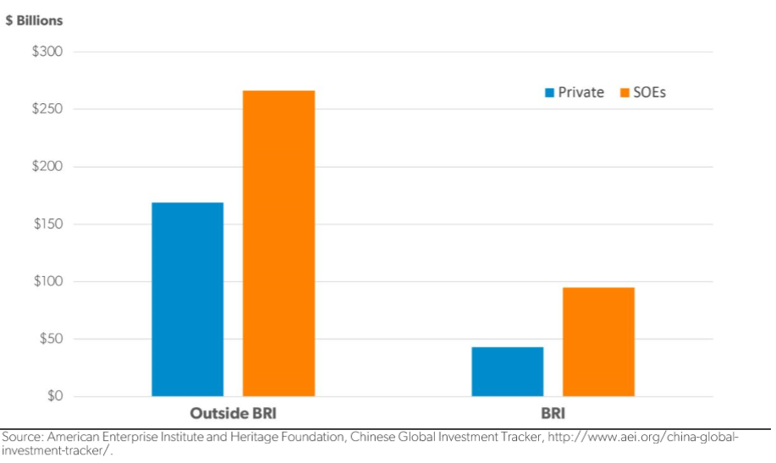

Figure 2: Private Share of Investment Inside and Outside of BRI
Private Share of Investment
 | BRI | Outside BRI
2014 | 28% | 28%
2015 | 17% | 40%
2016 | 28% | 51%
2017 | 49% | 33%
Source: American Enterprise Institute and Heritage Foundation, Chinese Global Investment Tracker, http://www.aei.org/china-global-investment-tracker/.

Figure 3: Investment and Construction in BRI Countries
Investment and Construction in BRI Countries ($ Billions)
 | Investment | Construction
2010 | 11 | 36.2
2011 | 19.1 | 30
2012 | 16.2 | 31.1
2013 | 30 | 43
2014 | 21.5 | 40.8
2015 | 41.9 | 48.6
2016 | 32.4 | 69.1
2017 | 42 | 49.1
Total | 214.1 | 347.9
Since BRI | 138 | 208
Source: American Enterprise Institute and Heritage Foundation, Chinese Global Investment Tracker, http://www.aei.org/china-global-investment-tracker/.
Figure 4: Yearly Change in Total Foreign Reserve Assets
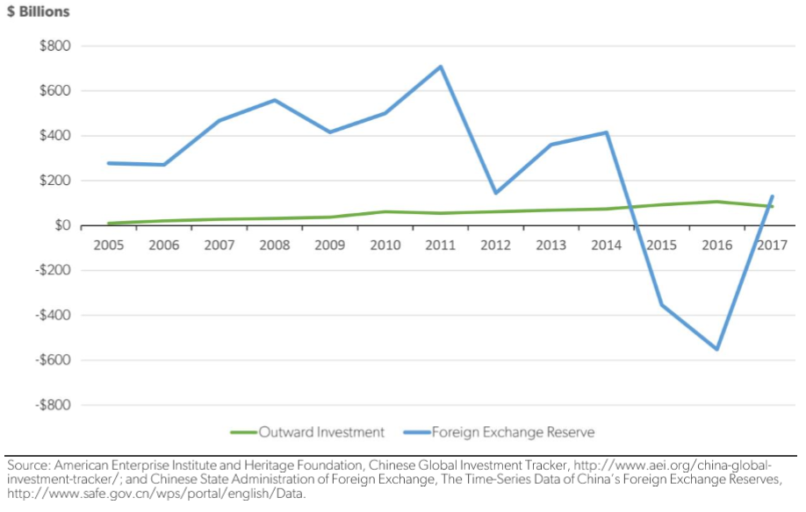

Figure 5: Sovereign Credit Ratings of BRI Countries (Hurley et al.)

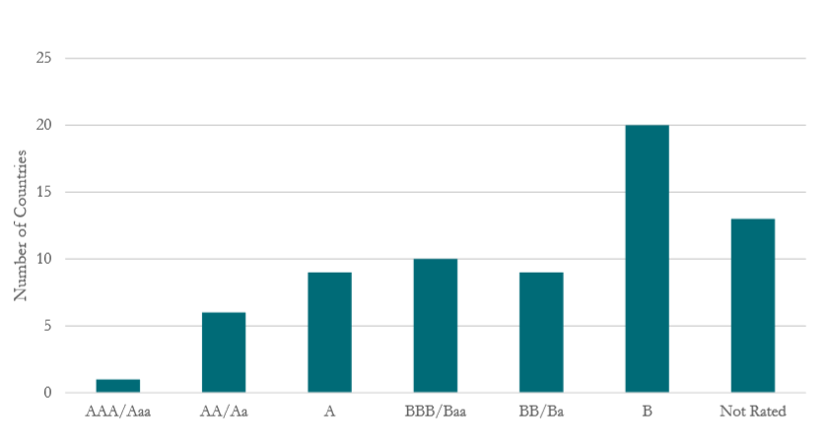

Works Cited
Abi-Habib, Maria. "Did China Get Sri Lanka to Cough Up a Port?" The New York Times, June 25, 2018. Accessed December 7, 2018.
Arduino, Alessandro, and Xue Gong. "Introduction." In Securing the Belt and Road Initiative: Risk Assessment, Private Security and Special Insurances along the New Wave of Chinese Outbound Investments. Singapore: Palgrave Macmillan, 2018.
Aschauer, David Alan. "Is Public Expenditure Productive?" Journal of Monetary Economics23 (1989): 177-200.
Brinza, Andreea. "China’s Continent-Spanning Trains Are Running Half-Empty." Foreign Policy, June 5, 2017. https://foreignpolicy.com/2017/06/05/chinas-continent-spanning-trains-are-running-half-empty-one-belt-one-road-bri/.
Cadot, Olivier, Lars-Hendrik Röller, and Andreas Stephan. "Contribution to Productivity or Pork Barrel? The Two Faces of Infrastructure Investment." Journal of Public Economics90, no. 6-7 (2006): 1133-153. doi:10.1016/j.jpubeco.2005.08.006.
Hurley, John, Scott Morris, and Gailyn Portelance. Examining the Debt Implications of the Belt and Road Initiative from a Policy Perspective. Center for Global Development. 2018.
Joy-Perez, Cecilia, and Derek Scissors. Be Wary of Spending on the Belt and Road. American Enterprise Institute. 2018a.
Joy-Perez, Cecilia, and Derek Scissors. The Chinese State Funds Belt and Road but Does Not Have Trillions to Spare. American Enterprise Institute. 2018b.
Kemmerling, Achim, and Andreas Stephan. "Comparative Political Economy of Regional Transport Infrastructure Investment in Europe." Journal of Comparative Economics43, no. 1 (2015): 227-39. doi:10.1016/j.jce.2013.08.002.
Kong, Bo, and Kevin P. Gallagher. "Globalizing Chinese Energy Finance: The Role of Policy Banks." Journal of Contemporary China26, no. 108 (2017): 834-51. doi:10.1080/10670564.2017.1337307.
Landry, David G. "The Belt and Road Bubble Is Starting to Burst." Foreign Policy, June 27, 2018. https://foreignpolicy.com/2018/06/27/the-belt-and-road-bubble-is-starting-to-burst/
Lawder, David. "Pakistan Likely to Pay Back IMF before Chinese Debt-U.S. Treasury Official." Reuters, November 27, 2018. https://www.reuters.com/article/us-pakistan-imf-china/pakistan-likely-to-pay-back-imf-before-chinese-debt-u-s-treasury-official-idUSKCN1NX0CI.
Liu, Dongmin, Haihong Gao, Qiyuan Xu, Yuanfang Li, and Shuang Song. The 'Belt and Road' Initiative and the London Market - the Next Steps in Renminbi Internationalization. Chatham House The Royal Institute of International Affairs. January 2017.
Parameswaran, Prashanth. "The Real Trouble With China's Belt and Road." The Diplomat, May 11, 2017. Accessed November 12, 2018. https://thediplomat.com/2017/05/the-real-trouble-with-chinas-belt-and-road/.
Sole-Olle, Albert. "Inter-Regional Redistribution Through Infrastructure Investment: Tactical or Programmatic?" Public Choice156, no. 1 (July 2013): 229-52. doi:10.2139/ssrn.1825021.
"Where Is the Funding for a $26 Trillion Initiative Coming From?" CNBC. March 06, 2018. Accessed December 7, 2018. https://www.cnbc.com/advertorial/2018/03/06/where-is-the-funding-for-a-26-trillion-initiative-coming-from.html.
Worthington, Andrew C., and Brian E. Dollery. "The Political Determination of Intergovernmental Grants in Australia." Public Choice94 (1998): 299-315.

