Yemen Health Analysis
12-page report
Emily Bryner, Lauren Danko, Makenna Hadley, Elsa Hanson-Schiffgens, Vishan Ramanathan
University of Pittsburgh
PUBHLT 1001: Introduction to Global Health
Dr. Cynthia Salter
November 24, 2020

Geography & Population
Yemen is located on the southern tip of the Arabian peninsula, bordering Saudi Arabia and Oman. It is situated at the entrance to the Red Sea which has historically been crucial for trade and remains to be one of the most active shipping lanes in the world. It is largely arid, mountainous, desert, which limits agricultural options, and also results in frequent droughts. The capital is Sanaa, which is located on this map at the red square, with Aden in the south being another prominent city. The population of Yemen is estimated to be around 28 million people, with an official language of Arabic and the state religion being Islam. The large majority of Yemenis consider themselves to be Arabs, but throughout the country there are some tribal and religious breakdowns specific to certain regions (Britannica, 2020).
Country Context
In recent years, Yemen has been subject to much violence and turmoil. In 2011, as revolutions now known as the Arab Spring swept across North Africa and the Middle East, discontent for the current president, Ali Abed Allah Saleh grew and protesters in the capital city of Sanaa called for him to step down. When he refused, protests turned more violent and he was forced to step down as his vice president took over but protests only continued. This war has ultimately morphed into a civil war, with factions from the north and south, backed by separate powers such as Saudi Arabia, the United States and United Arab Emirates, still fighting to this day (Wintour, 2019). These conflicts have left the country incredibly destabilized, with the large majority of the population in need of critical humanitarian assistance. With recent famines, droughts, and cholera outbreaks, foreign aid is crucial for the survival of most young Yemenis. Due to bombings and lack of infrastructure, more than 20 million Yemenis lack access to basic healthcare and as we know with malnutrition and diseases such as cholera, children are the most heavily impacted (International Medical Corps, 2020).
Economy and Demographics
Yemen has been considered a low-income country for decades. However, its poverty-stricken condition has only been exacerbated by the war. As a result of the civil war, Yemen is suffering from severe inflation. The Yemeni Rial has lost a significant portion of its value, shrinking by 50% over the course of the three years from 2015-2018. Currently, the Rial exchanges at a value of 800 rials to the U.S. dollar, its lowest value since the war began; (Gahlan, 2020). The country’s GDP was $31.27 billion in 2017, ranking 104th in the world, but it has one of the worst GDP/capita in the world. During the Arab Spring and again during the Civil War the GDP contracted significantly and it has not recovered since. Prior to these events, the GDP had been rising steadily. (Statista, 2020). The country has a few major exports, including oil, agriculture (including coffee), and textiles. Oil accounts for 25% of the country’s GDP but it is a resource that is severely depleted in the country. Furthermore, since the Yemen government has deals with many foreign investment companies, the country does not see much of the profit from oil as compared to neighboring Middle Eastern countries like Oman and Saudi Arabia (CIA - World Factbook, 2020). However, since the war started the country has halted a majority of its exports and does not have high domestic output to fall back on. The country requires heavy international assistance and since the war, 75% of the country has fallen below the poverty line, up from 50% pre-dating the war. Upwards of 40% of the country’s households lost their primary source of income and women suffer more from this crippling poverty than men (Worldbank, 2020).
The country of Yemen currently is home to 30 million people, but the size of that population is rapidly increasing. It is set to surpass 50 million people and begin to decline in 2080. The age structure remains very young, with a median age of 20.2 and a low life expectancy compared to the region and the world of 66 years. Continuously, only 37% of the population live in cities (mostly in the southwest) and the rest of the country lives in rural communities and the communities of Yemen are largely tribal. Many nationalities call Yemen home, including those of Arab origin, Turkish, Indonesian, Malaysian and refugees from Somalia, Iraq, and Ethiopia (Worldpopulationreview, 2020).
Demographic Transition and Epidemiological Transition
The country remains very young in the demographic transition. Although the fertility rate has fallen from 8.7 births per woman in 1975 to 3.84 births per woman today. Even though this is a dramatic drop, the age structure remains young and the fertility rate remains high when compared to the rest of the world/region. 50% of the country’s population are under the age of 15 (Madsen, 2010). Yemen’s population does not live long unfortunately, and the low life expectancy can be attributed to the dangers to teens and young children which include conflict terror and currently cholera which are discussed later. The country’s birth rate/1000 people has fallen dramatically as it was 56.2 in 1970 and is currently at 31. Continuously the death rate/1000 people have fallen from 29.5 in 1970 to 6 today. (The Worldbank, 2019) Even with these dramatic drops in birth and death rate, and the fact that stage III of the demographic transition is usually indicated by a falling death rate followed by a falling birth rate, Yemen remains in stage 2 of the demographic transition. This is because the population is still expanding readily, the population structure is extremely young, and the birth/death rate figures are still high for the region. This speaks to the non “all-encompassing” nature of the definition of the stage of the demographic transition.
Yemen still suffers from communicable diseases, including the cholera outbreak of 2017. Continuously injuries from conflict terror are high while non-communicable disease numbers are rising. The low contraceptive rate (33%) and lack of prenatal planning prevents the fertility rate from falling and the large rural population and lack of road infrastructure makes accessing health care difficult. (World Bank, 2019). Finally, in a country with only 30 million people, 20 million live without access to healthcare (World Bank, 2020).
Health Statistics
The most recent data from the WHO shows that Yemen has an average life expectancy of 66, specifically 68 for females and 64 for males. The fertility rate is 3.84 children per woman. The infant mortality rate is 31.35% and the under-five mortality rate is concerningly 68.65% (Yemen Country Overview). As previously mentioned, Yemen is in the midst of the worst humanitarian crisis in the world so statistics may not be entirely accurate since it is so difficult to collect data in times of conflict. The high infant and under 5 mortality rates are caused by malnutrition, infectious disease, poor prenatal care, and lack of clean water and food. War and conflict have left millions of people displaced and food/water insecure. Response from the world health organization has helped implement mobile clinics, vaccines, and feeding centers in Yemen. Humanitarian aid has been helpful with providing crucial medical care and emergency supplies however, conflict still has severe impacts on the country’s health (Yemen Situation Reports).
War and conflict have resulted in damaged infrastructure, leaving over 20 million people without access to clean water or basic sanitization. This war damage has caused the outbreak of cholera and other diarrheal diseases as well as causing a serious famine in Yemen. There have been over 2 million confirmed cases and over 3,000 deaths caused by cholera since 2017, making the cholera outbreak in Yemen the largest and fastest growing outbreak in history (Lyons). Lack of access to food and clean water as well as poor healthcare exacerbates the situation severely and the outbreak continues to thrive amongst Yemen’s most vulnerable people.
Malnutrition as mentioned earlier makes cholera and other outbreaks of diphtheria, measles, and dengue fever especially dangerous for young children (Federspiel). There has been aid from global health organizations, but the outbreak still continues to wreak havoc on Yemen.
Burden of Disease
The top causes of DALYs in 2019 for both sexes were neonatal disorders, congenital birth defects, conflict terror, heart disease, and diarrheal diseases such as cholera (Yemen, 2017). See figures 2 and 3 below to see the trends in leading causes of death and risk factors. Due to years of intense fighting in the country, access to crucial health care is limited. As conflict worsens, families are getting poorer and poorer, home births are on the rise, and women are only seeking medical attention if they experience complications. Lack of prenatal care and malnutrition leaves mothers and babies at much higher risk for complications during birth and birth defects. Over 2 million children under the age of 5 are malnourished in Yemen, leaving them at high risk for poor health in adulthood. Diarrheal diseases remain one of the main causes of death in children under five years old (Yemen, 2020).
Response to COVID-19
There have been approximately 2,073 confirmed cases of COVID-19 and 605 deaths in Yemen. These numbers are expected to be significantly undercounted due to challenges in collecting data in the conflict-plagued country. COVID-19 puts more weight on the shoulders of Yemen’s shattered healthcare system. Yemen’s hospitals and medical professionals are heavily targeted by conflict including airstrikes, ground attacks, military occupation, and violent assaults. Many healthcare providers fear for their lives and this stops them from coming to work and even drives some to flee to safer areas (McKernan). Due to this, there is a severe lack of medical doctors and supplies in Yemen. 20% of Yemen’s districts do not have access to a medical doctor. In addition, there are only around 500 ventilators, 60 of which are suitable for children, and only a few hundred ICU beds for severe cases in the whole country. Healthcare facilities must frequently turn away COVID-19 cases due to inability to care for the highly infectious patients and inadequate PPE for healthcare workers (Covid-19 quietly sweeps across Yemen). On a more positive note, the United States Agency for International Development has created a program that trains healthcare providers in Yemen on COVID-19 safety, preparedness, and response. Thus far, 611 doctors and nurses, including 299 women, have participated in sessions and it has been well received by providers responding to the pandemic (Supporting Yemen's Healthcare Workforce).
Health System & Health Programs
Yemen’s recent civil war and multiple communicable disease outbreaks have left its healthcare system on the brink of collapse. Already struggling to control communicable diseases and chronic malnutrition, when the civil war broke out in March 2015, Yemen today is seen as the world’s worst humanitarian disaster. Prior to the start of the conflict, it was estimated that about half of Yemeni citizens had access to healthcare facilities. Between the start of the war and now, there are more than 100,000 estimated to have lost their lives due to direct conflict, and 131,000 others to have died from indirect causes such as starvation and disease. The government agency that oversees the country's public health and demographics is the Ministry of Health. However, it is unable to support the country's health system, so only outside assistance, such as the International Medical Corps and the International Committee of the Red Cross, prevents it from total collapse. The International Medical Corps (IMC) is a global, nonprofit humanitarian aid organization dedicated to saving lives and relieving suffering by providing emergency medical services, as well as healthcare training and development programs to those affected by disaster, disease, or conflict. The IMC serves areas of Yemen with some of the most pressing humanitarian needs, even though widespread damage to existing infrastructure has restricted access to many areas. The Red Cross is supplying hospitals and health facilities with medicines and emergency medical supplies. They continue to work closely with the Yemen Red Crescent Society and the local authorities. The Yemen Red Crescent Society currently runs 24 health facilities around the country (Yemen on the Brink of Famine, 2020).
Efforts in the past to implement a national health insurance system never transpired. Even when sensible reforms to the health system were enacted, they ultimately always failed because of poor implementation and underfunding. This has led to a gap that has been attempted to be filled by a private health sector, however this is problematic as most Yemenis don’t have health insurance. Where public health benefits have been offered, they are usually tailored to maximize cost-sharing revenues and revenues from informal payments, instead of providing health care based on need (Fuss, 2016).
It is estimated that 20 million people lack access to basic healthcare (Yemen on the Brink of Famine, 2020). Currently, more than 50% of the country’s facilities have either been destroyed or damaged due to the conflict. Meaning only half are operational and are already struggling to cope with the overwhelming numbers of patients suffering from malnutrition, cholera, dengue fever, and injuries of war. In the few facilities that are running, they lack sufficient specialists, equipment, and medicine to help them successfully operate. As of 2004, there were only three doctors per 10,000 persons, compared to the international standard ratio of 41 to 10,000. Since the conflict started, many doctors and nurses fled the country as staying meant death. While some of the operating clinics have laboratories, they can’t carry out liver, kidney, and cholesterol tests because of the lack of equipment. Today, it is free for the patients to get tests done, but in the future clinics might be forced to demand payment, which is not going to be easy as citizens won’t be able to afford care (Health: Fact Sheet: Yemen, 2019).
Priorities in Health
Even before the current conflict that escalated in March 2015, Yemen faced enormous levels of humanitarian needs stemming from years of poverty, under-development, environmental decline, intermittent conflict, and weak rule of law. Recent intense conflict, as well as recent famine and cholera outbreaks, has put millions at risk. The major priority public health concerns include immunization, communicable disease management, disease surveillance and trauma care. As of July of 2020, there were more than 24 million people in need of humanitarian assistance and 20.5 million people who lack access to clean water and sanitation due to damaged water pumps and treatment facilities. These damages lead to the cholera outbreak of 2017, as well as the more recent outbreaks of dengue fever, influenza, measles, the reemergence of diphtheria, and risks the reintroduction of polio. While the clinics used to be able to vaccinate children, they are no longer able to provide this service as vaccinations need to be stored in a cold place, but because of the lack of electricity and fuel, this isn’t an option (Quick facts: What you need to know about the crisis in Yemen, 2020).
The hunger crisis has left over 20 million citizens food insecure, and over 10 million acutely food insecure. The number of children suffering from severe acute malnutrition has increased by 90% in the last three years. As of 2019, there were over 360,000 children under the age of five who suffer from severe acute malnutrition, creating irreversible stunting, wasting, and increased mortality due to starvation (Yemen on the Brink of Famine, 2020).
In order to implement change, the first step needs to be building the health system back up. As it is currently on the brink of collapse, all of the major health problems stem from this issue. There needs to be vaccination campaigns, better screening processes for malnutrition, and more access to medication and medical supplies. Overall, more aid to the country is needed as building the health system back is not going to be easy, nor is it going to be fast.
Trending Data
Yemen’s Human Development Index (HDI) value for 2018 is 0.463, putting the country in the low human development category and positioning it at 177 out of 189 countries and territories. The HDI measures the average achievement of key human development indicators, including a long and healthy life, being educated, and having an adequate standard of living. Since 1990, Yemen’s HDI has barely improved.
Figure 1 - Yemen Human Development Index from 1990-Present
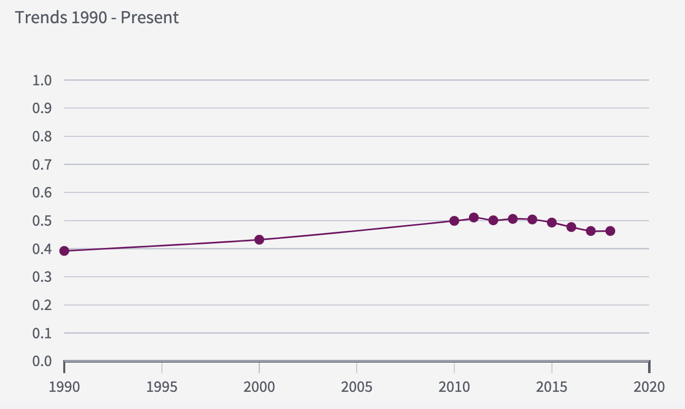
Ischemic heart disease remains the number one cause of death and neonatal disorders remains the number two cause of death, as demonstrated in Figure 2. Also, in 2007, conflict and terror was ranked 102. In 2017, though, its ranking increased significantly, by almost 70,000%, to the third most common cause of death in Yemen. Road injuries remain ranked in fifth because traffic laws are not enforced and rarely adhered to by motorists.
Figure 2 - Top 10 Causes of Death in 2017 and Percent Change From 2007-2017
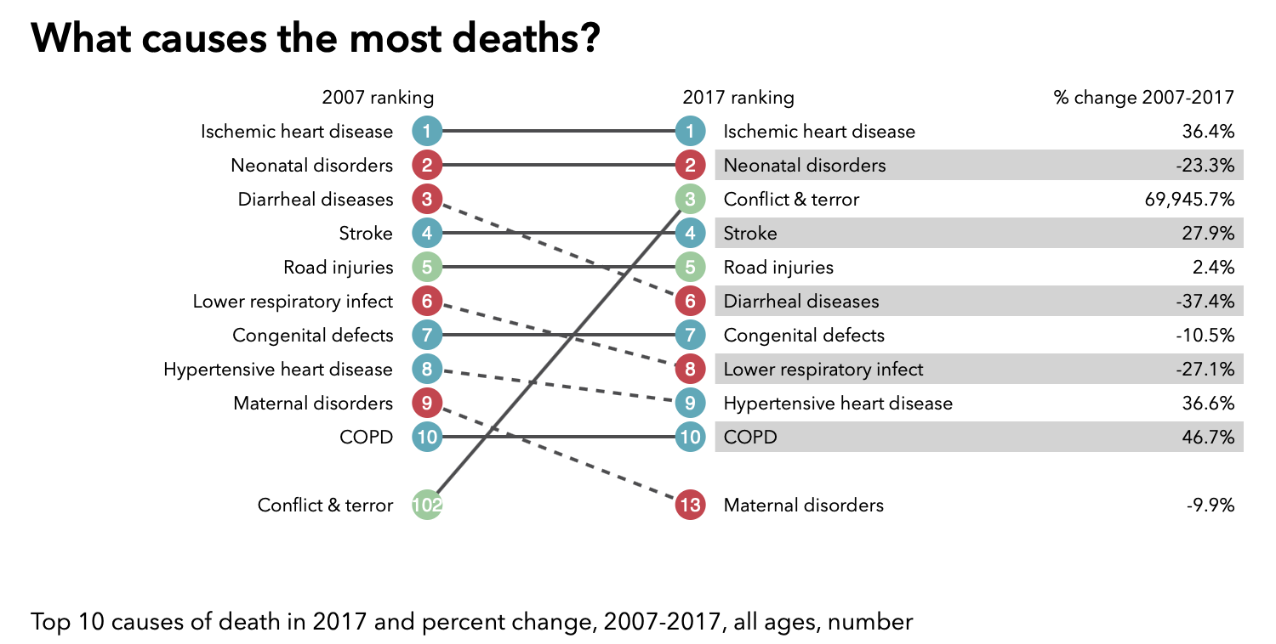
In Figure 3, the top three risk factors driving the most death and disability combined in 2017 include malnutrition, dietary risks, and WaSH. These risk factors have barely changed in ranking from 2007 to 2017. Lack of access to safe drinking water and sanitation systems has led to the continuous spread of diarrheal disease, the number six cause of death in Yemen.
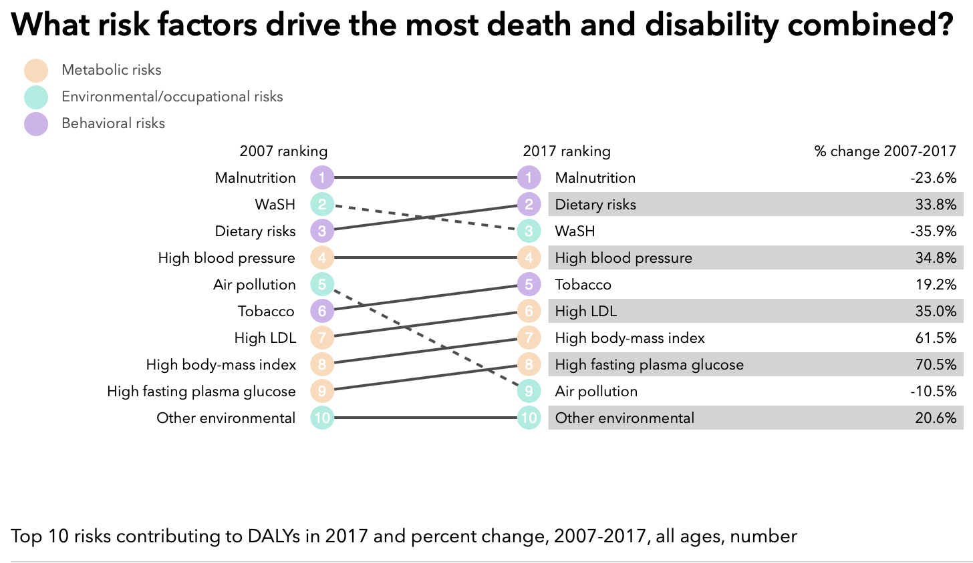
Figure 3 - Top 10 Risk Factors in 2017 and Percent Change From 2007-2017
Finally, from January to August 2020, the total number of suspected cholera cases was approximately 167,000 with 48 deaths. Compared to the same period in 2019, less cases have been reported, showing a 70% decrease in cases. Currently, the trend is considered as decreasing.
Expert Recommendations
The health issues in Yemen are worsened due to all of their humanitarian crises. As previously mentioned, airstrikes due to the conflict have resulted in damage to over half of Yemen’s health infrastructure. According to a report from USAID and the Johns Hopkins Center for Humanitarian Health, these attacks were “a major contributor to the maintenance of the infectious ecosystem of cholera in Yemen” (Potter, 2020). Thus, it is important to prioritize repairing these damaged facilities. Repairing water infrastructure, for example, would improve sanitation and hygiene to prevent diarrheal diseases. The rest of Yemen’s health facilities, which are currently “functional,” face severe shortages in vaccines, medical equipment, and clinical staff. If vaccinations and rehydration treatments were more plentiful in Yemen, cases of cholera could be controlled more effectively. The improvement of oral cholera vaccine campaign planning is one of the World Health Organization’s recommendations for the ongoing cholera outbreak. WHO also recommends health authorities focus on case management, surveillance and laboratory investigations, hotspot mapping, WaSH, and risk communication (“Outbreak update,” 2020). Increasing resources and improving care can be done by raising public health spending and contributions from Gavi Vaccine Alliance, the United Nations Children’s Fund (UNICEF), or other donors. In Yemen, because the civil war causes a lack of government control by one single entity, health care is mainly provided by humanitarian aid organizations. The different government entities, however, are blocking off many air and sea ports and prohibiting certain imports. As a result, humanitarian aid organizations are having difficulty importing food, vaccines, and medical equipment. Yemen must re-open ports or reduce limitations to prevent malnutrition.
Due to the urgency of the cholera outbreak and chronic starvation, pregnant women and newborns are limited in maternal and child health services. Only three out of ten births take place in regular health facilities, as home births are on the rise and women are only seeking medical care if they experience complications. Improving prenatal and postnatal care, as well as ensuring skilled health attendance at delivery, is essential to reducing home births and improving the chances of survival for mothers and babies. If war parties involved in the Yemeni Civil War ensure that humanitarian personnel will remain safe, the number of humanitarian healthcare workers will increase. Despite the support of aid organizations, approximately 98% of children with diarrheal diseases are unable to receive treatment during the mid-year rains (Suprenant et al., 2020). Thus, health care must be made more accessible by providing community outreach or other delivery modalities closer in proximity to those in need. Prior to and during these periods of heavy rain, diarrheal treatment locations should be examined in order to lessen the prohibitive travel burden. In the years since the conflict began, food prices have dramatically increased, mainly because fuel prices have also increased under the control of Sana’a-based authorities. The more expensive fuel is, the higher the food transportation costs are and the higher food costs are. The food insecurity crisis can be solved through controlling the fuel crisis in areas under control of Sana’a-based authorities. In order to rehabilitate those who are already malnourished, more therapeutic feeding centers need to be created.
Lastly, Yemen must reduce the amount of road injuries. Laws must be created to mandate the use of seatbelts and car seats for children. The maximum speed limit for private cars, which is 62.5 miles per hour, must be enforced more strictly (“Traffic and Road Conditions,” n.d.). Standards also should be set for taxi and public transportation safety and equipment, as many of these vehicles disregard other traffic and are in poor repair.
Since March 2015, WHO has made strides to improve the health situation in Yemen. They have done so by providing medical supplies and clean water, vaccinating children, distributing fuel to hospitals, deploying surgical and primary care teams, and establishing therapeutic feeding centers. Overall, although humanitarian aid organizations are providing some relief, the resolution of the conflict among all war parties would be the most effective solution to improving healthcare in Yemen.
References
Covid-19 quietly sweeps across Yemen. (2020). Retrieved from https://www.economist.com/middle-east-and-africa/2020/06/04/covid-19-quietly-sweeps-across-yemen
Federspiel, F., & Ali, M. (2018). The cholera outbreak in Yemen: Lessons learned and way forward. Retrieved from https://www.ncbi.nlm.nih.gov/pmc/articles/PMC6278080/
Fuss, M. (2016). Increasing Health Care Access in Yemen Through Community-Based Health Insurance. Indiana Journal of Global Legal Studies, 23(2), 795.
Health system in Yemen close to collapse. (2015, September 30). Retrieved from https://www.who.int/bulletin/volumes/93/10/15-021015/en/
Health: Fact Sheet: Yemen. (2019, November 07). Retrieved from https://www.usaid.gov/yemen/fact-sheets/health-fact-sheet
Lyons, K. (2017, October 12). Yemen's cholera outbreak now the worst in history as millionth case looms. Retrieved from
https://www.theguardian.com/global-development/2017/oct/12/yemen-cholera-outbreak-worst-in-history-1-million-cases-by-end-of-year
McKernan, B. (2020). Health workers targeted at least 120 times in Yemen conflict – report. Retrieved from https://www.theguardian.com/world/2020/mar/18/health-workers-targeted-at-least-120-times-yemen-conflict
Outbreak update – Cholera in Yemen, 02 August 2020 - Yemen. (n.d.). Retrieved from https://reliefweb.int/report/yemen/outbreak-update-cholera-yemen-02-august-2020
Potter, C. (2020, January 16). Largest cholera outbreak on record continues. Retrieved from
https://www.outbreakobservatory.org/outbreakthursday-1/1/16/2020/large-cholera-outbre
ak-on-record-continues-in-yemen
Quick facts: What you need to know about the crisis in Yemen. (2020, October 14). Retrieved from https://www.mercycorps.org/blog/quick-facts-yemen-crisis
Supporting Yemen's Healthcare Workforce: Program Update: Yemen. (2020). Retrieved from https://www.usaid.gov/yemen/program-updates/sep-2020-supporting-yemen-healthcare-workforce
Suprenant, M. P., Gopaluni, A., Dyson, M. K., Al-Dheeb, N., Shafique, F., & Zaman, M. H. (2020, August 5). A predictive model for healthcare coverage in Yemen. Retrieved from https://www.ncbi.nlm.nih.gov/pmc/articles/PMC7550854
Traffic and Road Conditions in Yemen. (n.d.). Retrieved from https://www.countryreports.org/country/Yemen/traffic.htm
Wintour, P. (2019, June 20). Yemen civil war: The conflict explained. Retrieved from https://www.theguardian.com/world/2019/jun/20/yemen-civil-war-the-conflict-explained
Yemen. (2020, October 15). Retrieved from https://www.britannica.com/place/Yemen
Yemen. (2020, September 29). Retrieved from https://internationalmedicalcorps.org/country/yemen
Yemen. (2017). Retrieved from http://www.healthdata.org/yemen
Yemen Country Overview. (2020). Retrieved from https://www.who.int/countries/yem/en/

Yemen on the Brink of Famine. (2020, September 29). Retrieved from https://internationalmedicalcorps.org/country/yemen/
Yemen situation reports. (2017). Retrieved from https://www.who.int/hac/crises/yem/sitreps/en/

