Group: Algeria
11-25-17
Professor Fatma El-Hamidi
Final Paper

Discussion of the Lack of Algerian Economic Diversification
Many nations in the Middle East and North Africa region are highly dependent on a very small number of industries as catalysts for economic growth. For countries like Algeria, maintaining steady, non-cyclical growth can be quite difficult when 95% of export revenues are derived solely from oil (OEC).
To provide a brief history, Algeria was occupied by the French for nearly 125 years until 1962 when it gained independence. Upon gaining independence, Algeria was unable to diversify its economy and retained its heavy dependence on foreign nations. From 1962 until the present day, Algeria has still failed to meaningfully diversify its economy and remains heavily dependent on exports of oil (and other hydrocarbon products such as natural gas). The country’s economy experienced the negative effects from its reliance on these revenues in the form of high unemployment coupled with volatile cash flows to use for domestic investment. Recently, as the landscape of energy supply and demand experienced by the country shifts, Algeria has been even more affected.
These most recent economic shifts seem to be more permanent and long lasting than any before. In turn, the underlying problem Algeria faces today and has faced since gaining independence is exposed and we must ask: what steps can we take in both the short and long term to mitigate the risk of slowing growth and higher unemployment? In the past the policy was to simply weather the storm, yet today this is no longer an option for Algerian policy makers. Algeria is taking steps to diversify itself with the minimal resources it has. For example, the country experienced shifts in foreign investment that are making a difference in diversification. During the time period following independence up until the start of the Algerian Civil War during the 1990’s the World Bank was a primary foreign investor. However, following the end of the civil war, upon the turn of the century, Algeria found a new investor: China. As Algeria must make a transition from being solely reliant on its exporting of oil for GDP to a more diverse economy, Algeria began to develop a strong relationship with China. A relationship based on increasing Chinese financial investment in Algeria that is beginning to lead to improved development and ultimately larger trading volumes between both nations.
Therefore, in this paper, we will discuss how Algeria’s economic problems, such as unemployment, arose from its continued reliance on mineral exports despite the declining global energy demand and analyze to what extent economic diversification and foreign investments have addressed these issues. We hypothesize that economic diversification and foreign investments would have positive effects on the economy, specifically on the minimization of unemployment.
The current debates and arguments in academic literature provide insight into these topics. In the following paragraphs, we discuss some pieces of the literature that together capture the main arguments on Algerian economic problems with and attempts to fix the country's reliance on oil exports.
When reading the pertinent literature, the first question that arises is: why has Algeria seemed to fail at diversifying in the past? Perhaps an answer can be found in Algeria’s history. As stated above, French colonization from 1830-1962 meant that the country developed a strong dependency on foreign nations. In 2012, Abdallah Zouache says in his article, “The economics of Algeria since independence”, “the paradigm inherited from colonization failed since Algeria has still not converged to high standard of living, despite the hydrocarbon rent,” (Zouache, 2012). With a rising population and a shrinking GDP, Algeria needs to figure out a way to adapt sooner rather than later.
Because the Algerian economy struggled to grow its GDP and private sectors after independence, the Algerian government has passed numerous policies to help accelerate growth. Starting within just 15 years of independence. According to Abdallah Zouache, Algeria passed the 1976 National Act, which aimed towards supporting the industrial sectors of the economy such as chemical, steel, and hydrocarbon industries. The purpose behind this legislation was to help diversify the risk that Algeria faced with such a high dependence on the oil and gas industries and to reduce the unemployment felt among citizens. Zouache then provides statistics of investment in Algeria, which saw an investment rate of 28.3% from 1970-1973, 40.4% between 1973-1978, and a peak rate of 47.8% in 1978. This benefitted Algeria by providing the means to develop these sectors, while also making the transition to privatizing the sectors, as seen in later legislation, much more attainable.
Another couple decades later, amidst a sort of “civil war”, alternatively labeled as a military coup, Algeria continued its push for privatization and control of inflation rates, which had spiked due to the socioeconomic issues of the governmental conflict. Two International Monetary Fund (IMF) policies were placed into effect, one spanning from 1994-1995 and the other from 1995-1998. The first policy focused on tightening the monetary policy to control the high inflation rates prominent in Algeria, while the second pushed for privatization throughout many industries and a market-based economy, especially in steel, hydrocarbon, and chemical departments. In response to these policies, Algeria saw a dramatic decrease in the inflation rate, which fell from 30% to 5.7% between 1995-1997. However, this did lower GDP growth to just 1.2% and spiked the rate of unemployment to around 27% and yet it did not see much improvement on the privatization side of the legislation (Zouache 4).
In the early 2000s, the Economic Recovery Program (ERP) was passed to stimulate aggregate demand and lower the high unemployment levels through public investment in infrastructure and human development. Because of the ERP, unemployment reduced from 28% in 1998 to 15.3% by 2005 and annual employment growth increased, with construction seeing a 5% increase from 3% to 8% and total employment increasing from 39% in 1997 to 49.1% by 2005 (Zouache 5). The ERP helped Algeria regain its footing after the spikes in unemployment from the IMF policies, and hoped to provide the groundwork for privatizing industries further.
In 2015, Algeria exported $37.7B, good for 52nd best export economy in the world. Of this $37.7B, $35.9B, or over 95% of the exports, consisted of “mineral products” (“Algeria” OEC). This category includes petroleum gas, crude petroleum, and refined petroleum as well as other oil related goods (“Algeria” OEC). Quite clearly, Algeria’s economy can be described as reliant on oil to say the least. The reliance can also be seen through its GDP as non- oil and gas industries account for no more than 5% of GDP (“Algeria Economic Outlook 2017” 242). Despite recent efforts to diversify the economic one dimensionality, Algeria has work to do. “The IMF projects an average annual GDP growth below 4% through to 2017,” (PwC report on “Algeria”), which objectively put is not great.
In PwC’s article “Algeria”, the consulting firm takes a closer look at the steps Algeria is taking in recent times to continue with their industrialization. The 2010-2014 5-year plan places over $286 billion into infrastructure and human capital, while continuing to push for privatization in its major industries of steel, chemical, and hydrocarbon. It also aims to diversify the economy so less emphasis is placed on the oil and natural gas industries. The 2015-2019 5-year plan then halted this investment in infrastructure, after oil prices dropped and the budget was tightened. It also planned to freeze the hiring of government workers and focused on limiting the number of imports into Algeria to help with the current account deficit of the nation (“African Economic Outlook 2015” 234). Time will tell how Algeria’s economy responds to yet another push towards privatization, but until now the country’s reliance on state-owned industries dominating the GDP makes for a hard transition to entrepreneurs and investors taking over the economy.
Recently, the country also took a step back in trade balance as a whole. A move that the country had been successful with over the past decade and a half. Since 2000, Algeria has consistently exported significantly more product then it has imported. However, in 2015 this trend flopped as Algeria imported $52.4B compared to the $37.7B of exports as mentioned before (“Algeria” OEC). Less reliance on oil by a vast majority of Algeria’s trade partners is perhaps a reason for this step back. Specifically, this includes, the rise in alternative energies in many developed countries, such as Algeria’s biggest export market: the United States. The United States alone accounts for roughly 20-25% of Algerian exports (PwC report on “Algeria”).
Specifically looking into global energy demand and its effects on Algeria’s economy, as of 2010, due to growing electricity demands not only on a global scale but also internally due to urbanization in Algeria, the Algerian government has taken to announcing a new law to further renewable energy production in the country. This being a primary decision made by an Algerian government trying to “meet the growing electricity demand and at the same time take care of the shrinking fossil resources and reduce global CO₂ emissions” (Stambouli, 2010). The article outlines how Algeria is beginning the process of building a solar energy field in the Sahara to offset its dependence on oil and natural gas (Stambouli 3508). Stambouli also mentions how energy production has shifted from predominantly oil to more natural gas extraction as oil is becoming increasingly scarce in the region (Stambouli 3508).
With energy demands shifting due to prospective shale gas in the US, oil prices in recent years have fallen. Although, the current Government’s plan “has essentially not moved beyond the previous program, a model of state-driven development, paid for with petrodollars,” (PwC report on “Algeria”), Algeria is beginning to look at improving its other economic sectors and developing renewable energy sources. The PwC report on “Algeria” provides relevant information and statistics from 2016 some of which are given above. The country is pushing to increase its energy output to 8,000 MW by 2016, putting it at around 20,000MW by 2020 and investing in renewable energy, transportation, and industry (PwC report on “Algeria”).
This change in the means by which Algeria pays for economic development and the process it undertakes to develop projects has led to China coming to the forefront, a phenomenon explained by Janvier Liste, et al. (2012) in the document titled “Chinese Investments and Employment Creation in Algeria and Egypt.” The Chinese have steadily increased their FDI (Foreign Direct Investment) in Algeria over many years. Most notably, with western influence being dominant until the early 2000’s, the Chinese have benefited from the poor impression left by the west during its tenure in Algeria. While there was a period of time in which the west dominated influence in Algeria, China’s relationship there dates back to when it first gained its independence in 1962 as China was the first non-Arab country to acknowledge Algeria as an independent nation (Liste). After a period of very little interaction between the two nations, China began looking at Algeria as a supplier of natural resources which it might be able to begin leveraging. In the early 2000’s China started to take note of Algeria’s gaining security stability and the optimistic outlook of Algeria’s economy. Primarily, China gained influence by providing development resources for the construction of low-cost government housing (Liste). After winning a contract to develop these facilities, Chinese State-Owned Enterprises were able to succeed in gaining many new infrastructure projects. Most notable, was the construction of the East-West High Project and expansion of Algeria’s railway networks (Liste).
China’s ability to provide extensive production capabilities for both goods and infrastructure have positioned China to have leverage in Algeria. In 2012, manufactured goods, machinery, and transport equipment accounted for nearly 91% of all Chinese imports to Algeria (PwC report on “Algeria”). In comparison, developed nations on average import roughly 60% of these same economic sectors (PwC report on “Algeria”). This significant proportion of imports from China provides a picture of the resources it can provide and their effectiveness.
In conclusion, Algeria has been and is currently facing problems due to its reliance on oil and natural gas revenue. The Algerian government along with several other actors, such as China, have attempted to combat this problem by diversifying the Algerian Economy and introducing new industries while supporting existing one.
As previously stated, Economic diversification is the key to a successful Algerian economy, a country that has been considered a rentier state (one that relies heavily on oil and natural gas exports) (Teulon and Fernandez). As scholars have noted, diversification has been a clearly necessary development strategy for the country since independence (Zouache). In the following section, we will analyze data to show how the lack of diversification in the Algerian Economy has affected its economy as a whole and to what extent changes the country has made to address the problem have succeed.
Specifically, we will first address how the lack of diversification in the Algerian economy has become a pressing issue due to the decreasing energy demand in Algeria’s most prominent export markets, the U.S. and the E.U. Also, statistics and data on the extent to which Algeria exports mineral products will show the focus on the oil and gas industry and a discussion of unemployment data will clearly show that a dependence on a non-human capital-intensive industry creates major problems for the country. 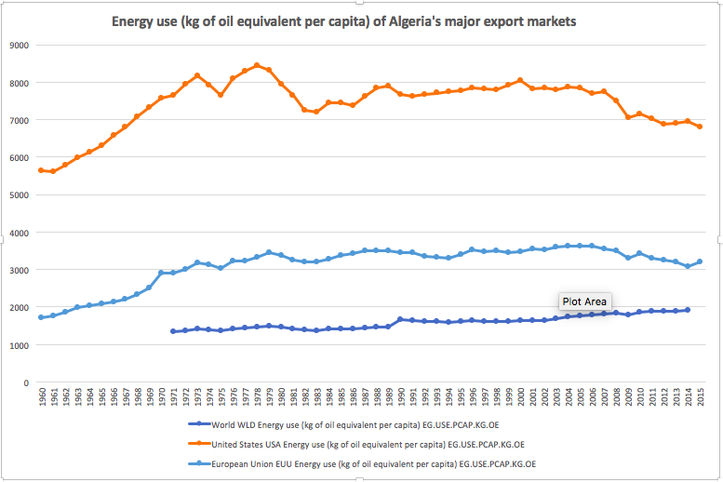
Figure 1 – Energy use (kg of oil equivalent per capita) from 1960 to 2014 (The World Bank Group 2014)
Figure 1 above indicates energy use of the World, the U.S., and the E.U. in kilograms of oil equivalent per capita . The chart spans from 1960 to the most recent data available, 2014. The energy use of a country will give insight into the energy demands of the country and thereby their import needs. The U.S. and E.U. are major importers of Algerian energy. Specifically, the U.S. is Algeria’s biggest export market of 20-25% (PWC). By showing the energy use of the U.S. and E.U., as well as the world in general, over the last half century we can infer their energy demand. Through this, trends in the Algerian economy are explained because as energy demands
from the U.S., E.U., and the world increased, Algeria exported more oil and could rely more heavily on the industry.
However, as the graph shows, energy use in both the U.S. and E.U. decreased after 2000. This downturn is likely due to the push in many developed countries to be more energy responsible. Also, one interesting year to note is 2009. Each country/region’s energy use during this year dips due to the world economic recession that decreased the world's energy demand. Less demand from both of Algeria’s top export destinations means a decrease in oil revenues for Algeria. This has dire consequences for the Algerian economy as it relies heavily of energy exports. Since 2000, oil has made up at least 95% of the country’s total exports every year (OEC). This cannot be sustained with the decreased demand of oil.
Before looking at the data, we expected to see a steady and relatively steep increase in global energy use as more and more countries industrialize. This was the case for world energy consumption. Also, we expected a less prominent decline in energy use after 2000 because of our preconceived notion about the difficulty of reducing energy use.
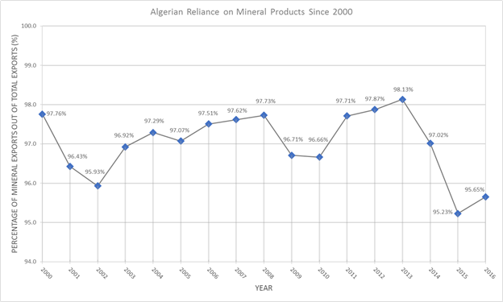
Figure 2 - Algerian Reliance on Mineral Products Since 2000 (OEC)
The relationship between Algeria and oil has long been prevalent. When looking at Figure 2, it is quite clear just how dependent on oil Algeria has become. As stated previously, since 2000, oil has made up at least 95% of the country’s total exports every year (OEC). The drops seen in 2002 and 2015 may seem significant, but in reality, are only less than 2% drops from the previous years. By comparing Algeria’s energy exports to those of Kuwait the extent to their dependence on oil becomes clear. Kuwait’s oil exports, a GCC country that is much smaller than Algeria, made up only about 85% of the total exports in 2016 (OEC). Diversification is necessary for Algeria to go forward, and perhaps the positive trend in recent years shows diversification is beginning to happen. The year 2013 represented oil’s highest percentage out of the total exports in the past 16 years at 98.13%. That figure has steadily dropped, reaching a low of 95.23% in 2015. This trend, although small in both sample size and significance, is showing the beginning diversification of a very lopsided economy.
It is not to say that Algeria should simply abandon exporting oil. China imported about $275 billion worth of mineral products in 2016. Yet, of that $275 billion, very little, less than 1%, comes from Algeria. Conceivably there is a market for Algerian oil products in China, but undoubtedly it cannot be the only dimension to the Algerian economy.
Unemployment in the early-1990s to the beginning of the 2000s was a major concern for the Algerian economy, especially for the educated population. With overall unemployment rates well above the 20%-mark for the decade, and with youth unemployment rates breaking 40% for all but one year, the lack of diversification evidenced by the dependency on oil in the GDP and exports in Algeria clearly is taking a toll on the economy.
Of Algeria’s total unemployment rate from 1991-2016, Algeria previously faced upwards of 20% unemployment for a span of 12 years, with a tail-off in more recent years still above 10%. Such high unemployment rates are attributed to Algeria’s lack of diversification in its economy. What little jobs there are fall into the public sector of the economy, which consists of mainly capital-intensive jobs such as those involved in the state-run energy industry, while the private sector, which makes up a small part of Algeria’s economy, struggles to benefit from the large labor force.
The story behind the high unemployment goes beyond just these sectors, though. The World Bank provided more in-depth data, seen in the Figure below, with regards to the unemployment rates of those ages 15-24.
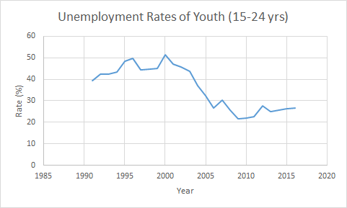
Figure 4 - Unemployment Rates of the Youth Population aged 15-24 from 1991 to 2016 (The World Bank Group 2017)
The trend of the youth unemployment graph is very similar in shape to that of the overall unemployment, yet the youth graph is shifted vertically along the y-axis to depict much higher values of unemployment among the youth, specifically newly-graduated workers. The graduates are not accepting as many jobs in the smaller private sector of the economy as in the larger public sector, explained in part by the revenue that each sector receives. The public sector contributes an astounding amount to Algeria’s GDP, whereas the labor-intensive jobs in the private sector contribute very little in comparison. This results in plenty of revenue for the public sector to hire workers, while the private sector may not have the funds to support this.
Another significant factor in the unemployment rates comes in terms of the wages received by the workers. Having such a plentiful amount of revenue, the public sector is able to offer higher wages than the private sector, and hence draws a lot more interest from the workers in the labor supply. The public sector obviously is not able to afford such a supply of labor, and hence sets its demand much lower than the supply of labor. This results in unemployment, and with such a large imbalance of public vs. private sector in GDP, it is only logical that Algeria faces a high unemployment rate for its workers, especially those who are educated but have little experience in the professional realm.
Next, we will focus on Algeria’s attempt to combat the problem of little diversification in recent years by investing in infrastructure, human development and Chinese investment in industrialization. Also, we will examine to what extent this investment has benefited the Algerian economy, specifically looking at changes in the unemployment rate.

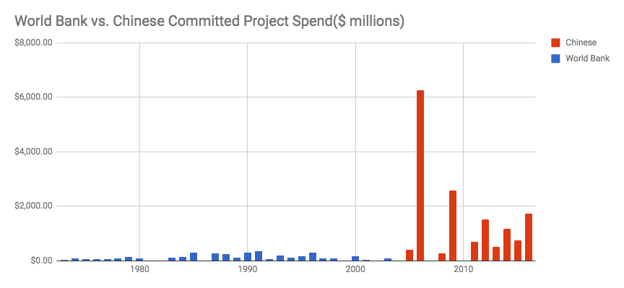
Figure 5 - World Bank vs Chinese Committed Project Spending (Sources: AEI & The World Bank Group)
It is evident in graph 5 that The World Bank’s spending began to decrease and then ultimately stop entirely after Algeria’s civil war. For nearly 4 decades after first gaining independence The World Bank had been Algeria’s primary source of knowledge, infrastructure, and finances to aid in developing themselves as a nation. At the turn of the 21st century this began to change. The World Bank began to significantly pull back its resources as China began to gear up on its desire to be a extremely influential global power. China, seeing this time period as a massive opportunity to penetrate the region, began to establish itself as a perfectly capable partner to replace the World Bank’s efforts in Algeria. Algeria has received only $370,000 USD since it virtually ceased its operations in 2003. At this point, China has clearly taken over a Algeria’s primary partner and resource for continuing to further develop as a nation. China is playing a primary role in helping Algeria solve its problems of oil exportation dependence and decreasing unemployment levels. The way that China is doing this is that they are able to provide Algeria with the vast resources it needs in order to rapidly industrialize. Moreover, it seems that China is investing itself in different types of development projects which seem to be having a much more positive effect than the World Bank’s efforts in terms of industrialization in Algeria.

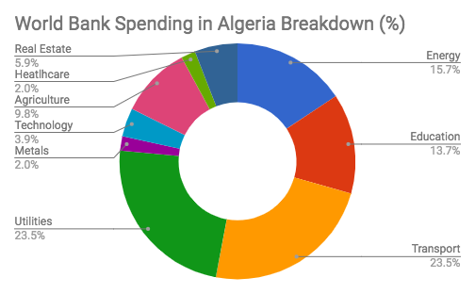

Figure 6- World Bank Spending in Algeria from 1955 - 2003 (Source: The World Bank Group)
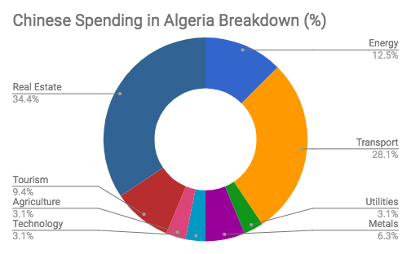

Figure 7- China Spending in Algeria from 2005 - 2016 (Source: AEI)

In the chart above it can be clearly seen that the Chinese have allocated a significant portion of their spending on developing real estate in comparison to the World Bank whom did not at all. A conclusion can be drawn from this which suggests that a key support to industrialization is real estate development.
For a country like Algeria to industrialize they certainly have a long road ahead. It seems however that the partnership they have with China will give them the means to successfully industrialize parts of their economy leading to lower levels of unemployment and far less reliance on the exportation of oil to sustain GDP. We can see how this has already worked by looking at unemployment in recent years. It is prominent how sharp the unemployment rate drops in Figure 3 above, from 29.77% as seen in the World Bank’s data in 2000 to 17.7% by the end of 2004, while youth unemployment drops, seen in Figure 4 above, from 51.42% to 36.88% in the same amount of time. As Zouache writes, the ERP’s investment in public investment in infrastructure and agriculture, along with our analysis of China’s investment in industrialization, helped to stimulate an absorption of high unemployment. The unemployment rate continues to drop amidst Algeria’s 5-year plan to continue its investment in infrastructure and human development and China’s involvement, reaching an all-time low of 9.82% in 2013 for overall unemployment, and a 25.06% unemployment rate for the youth in the same year, (“African Economic Outlook 2015” 243).
By diversifying the economy in Algeria, less of an emphasis can be placed on the public sector to carry the GDP in Algeria, and wages can be more spread across public and private sectors as private companies can reap some revenues from an increased contribution to the GDP in Algeria. This in turn has resulted in lower unemployment rates, both overall and for young workers, as more and more workers are able to accept private employment opportunities rather than wait for the next opening in the public sector. Through policy decisions by the Algerian government and strategic investments in infrastructure, human development, and industrialization Algeria has been successful in lowering its unemployment rates for both the overall population and the youth population alike, and must continue to diversify to aid in the growth of its economy.
In conclusion, the overall trend we hoped to see in our data was a move away from a primarily oil exporting economy to a more diverse one that would also help lower unemployment and strengthen the Algerian economy as a whole. This was confirmed by our data to a large degree. We were able to track how the lack of diversification in the Algerian Economy has affected its economy as a whole and to what extent changes the country has made to address the problem have succeed.
In regard to Algerian economic policy, Algeria has seen numerous instances of governmental influence, as shown by the ERP implemented in 2005 and the two IMF policies aimed at controlling inflation rates and privatizing the Algerian economy. While these policies worked to some degree, they merely lessened the hardships rather than turn the economy around. To continue on the upwards swing seen in our data, it is recommended that Algeria continues to privatize its sectors and diversify the economy to lessen the strain on the oil industry. Policy recommendations for the privatization of its sectors would be implementing a way of selling large State-Owned Enterprises (SOEs) to investors. This would open up job opportunities in the private sector and help with unemployment rates rather than having the public sector be the main focus of job supply.
Another policy recommendation with regards to diversify its economy would be to continue to allow foreign investment to aid in the financing of markets other than oil. As evidenced by China’s role in industrialization in Algeria, opening the gates to more investors will equip Algeria with the funds necessary to lessen the burden felt on the oil industry to supply all the revenue for the GDP, open up more job opportunities in a large range of sectors, and strengthen the economy as a whole.
Conclusively, since gaining its independence from France in 1962, Algeria has suffered economically. Perhaps the single biggest cause of the poor economic climate is the lack of economic diversity in Algeria. Huge percentages of Algeria’s exports come from the oil sector, and there is very little production elsewhere. Our goal was to show to what extent a one-dimensional economy, like Algeria’s, and economic troubles, like unemployment, are related. The data compiled undoubtedly supports this claim and shows the significance of the problem Algeria faces. That problem only grows in severity when one considers the global trend of lessening demand for oil and oil products. As alternative energy sources grow in number, the need for fossil fuels diminishes.
The country’s relationship with China helped push the economy in the right direction. Key factors have shown positive trends following China’s emergence in Algeria. Despite the huge challenges the country still faces, there have been small signs of diversification in recent years. We had hypothesized that this diversification as well as foreign investment would have a positive effect on the economy and the data shows that this is in fact the case.
Works Cited
Aei.org, American Enterprise Institute, www.aei.org/china-global-investment-tracker/.
“African Economic Outlook 2015.” OECD Publishing. 2015.
“African Economic Outlook 2017.” OECD Publishing. 2017.
“Algeria.” OEC – Algeria (DZA) Exports, Imports, and Trade Partners. Web.
Educational Research Journal. Vol. 5. Pg, 32-37. January 2017. Print.
“Energy Use (Kg of Oil Equivalent per Capita).” World Bank Databank, World Bank, 2014
Liste, Janvier, et al. “Chinese Investments and Employment Creation in Algeria and
Egypt.” Afdb.org, African Development Bank, 2012,
Stambouli, Amine Boudghene. “Algerian Renewable Energy Assessment: The Challenge of Sustainability.” Energy Policy, 9 Nov. 2010, pp. 4507-4519.
Pairault, Thierry . “China's Economic Presence in Algeria.” Halshs, 13 Feb. 2015.
“Projects & Operations.” Projects & Operations - All Projects | The World Bank,
projects.worldbank.org/search?lang=en&searchTerm=&countrycode_exact=DZ.
Teulon, Frédéric. “Industrialization and Economic Policy in Algeria: a Synthesis over half a Century.” IPAG Business School. 2014. Web.
“Unemployment, total (% of total labor force) (modeled ILO estimate).” The World Bank Group. 2017. Web.
Watkins, Thayer. “The Economy and Economic History of Algeria.” San José State University. Web.
Youcef, Souar. “The impact of workforce on industrialization in Algeria with the existence of expenditure in education as a variable mediator from 1970 to 2014.” African
Zouache, Abdallah. “The economics of Algeria since Independence.” Vlaams Marxistisch Tudschrift. 2012. Web.

[1] Kilogram of oil equivalent is a way of comparing energy sources; it is a conversion of various types of energy into how much energy comes out of one kilogram of oil, allowing researchers to accurately compare energy data.

